**Name**: Paramprakash Makwana

**Module 4 – Introduction to DBMS(Lab)**

Lab 1.1: Create a new database named school_db and a table called students with the following columns: student_id, student_name, age, class, and address.

Ans:- CREATE DATABASE school_db

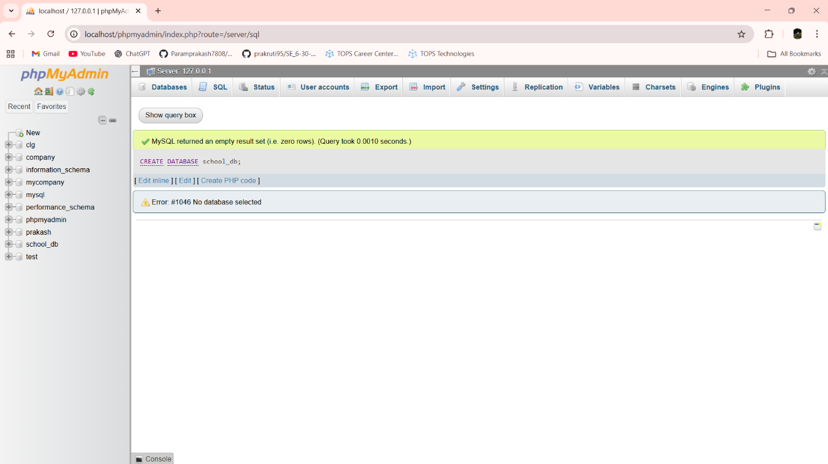

CREATE TABLE students (student_id int PRIMARY KEY AUTO_INCREMENT,student_name varchar(30),age int,class varchar(30),address varchar(50))

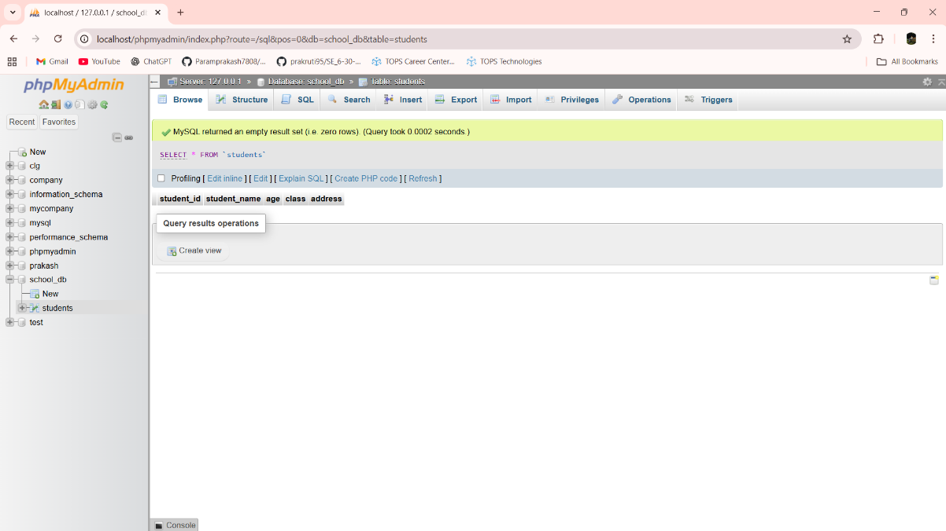

Lab 1.2: Insert five records into the students table and retrieve all records using the SELECT statement.

Ans:- INSERT INTO students (student_id,student_name,age,class,address) VALUES (101,'Prakash',21,'8TD2','Morbi Road Bedi Village Rajkot')

INSERT INTO students (student_id,student_name,age,class,address) VALUES (102,'Sahil',22,'1TD2','Morbi Road Bedi Village Rajkot')

INSERT INTO students (student_id,student_name,age,class,address) VALUES (103,'Ajay',21,'2TD2','Morbi Road Bedi Village Rajkot')

INSERT INTO students (student_id,student_name,age,class,address) VALUES (104,'Nik',22,'3TD2','Morbi Road Bedi Village Rajkot')

INSERT INTO students (student_id,student_name,age,class,address) VALUES (105,'Mayur',20,'4TD2','Morbi Road Bedi Village Rajkot')

SELECT * FROM students

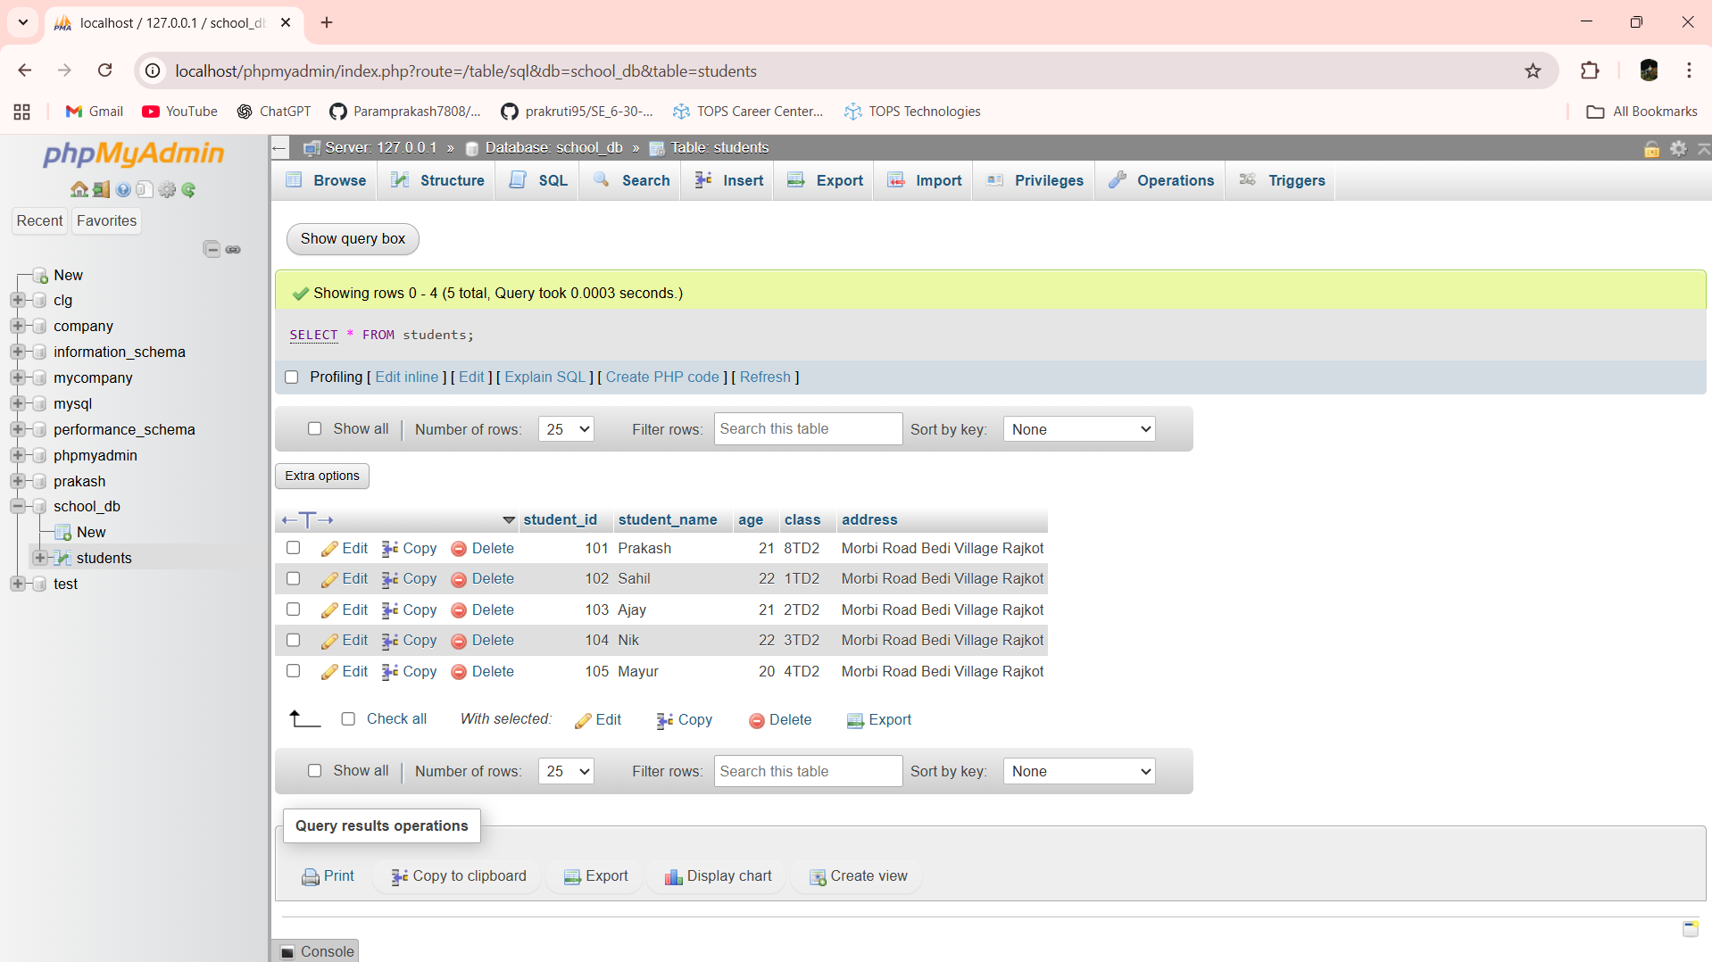

Lab 2.1: Write SQL queries to retrieve specific columns (student_name and age) from the students table.

Ans:- SELECT student_name,age FROM students

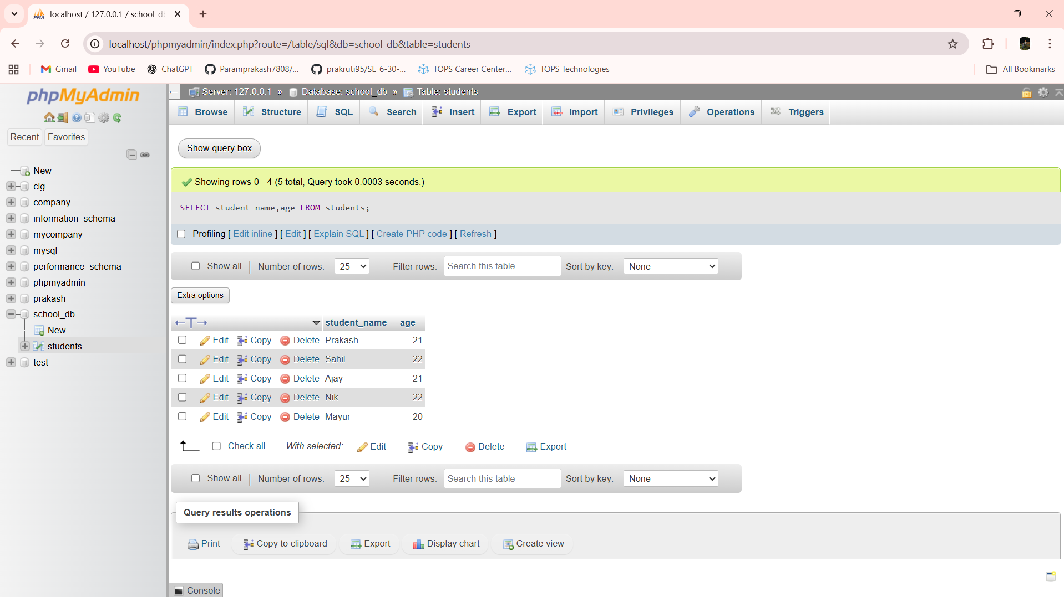

Lab 2.2: Write SQL queries to retrieve all students whose age is greater than 10.

Ans:- SELECT * FROM students WHERE age > 10

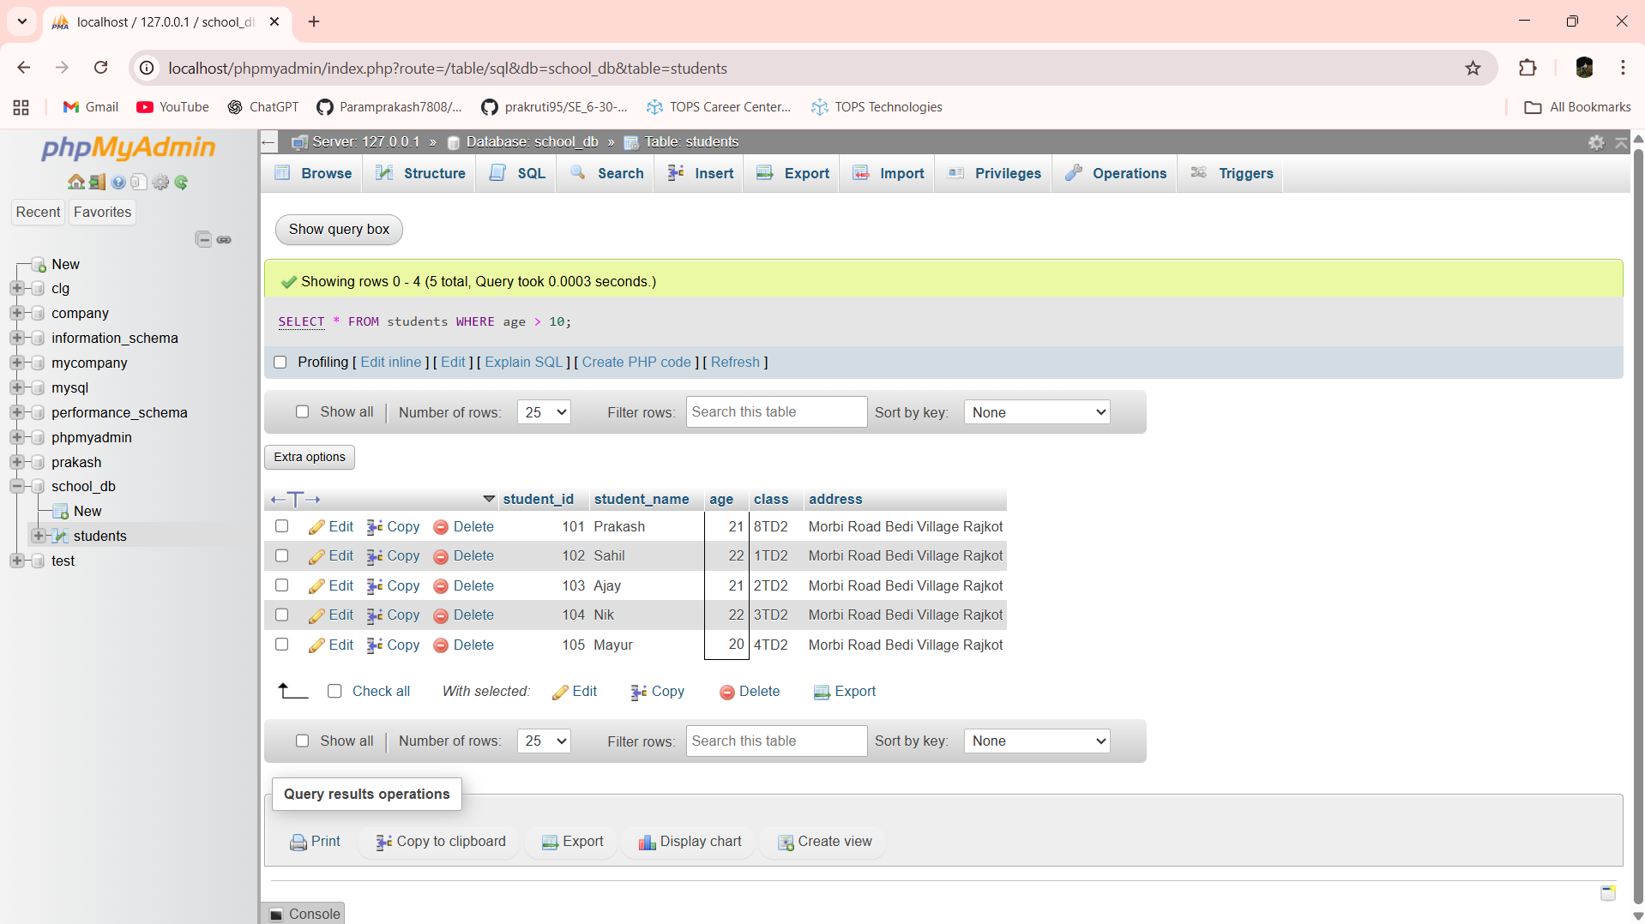

Lab 3.1: Create a table teachers with the following columns: teacher_id (Primary Key), teacher_name (NOT NULL), subject (NOT NULL), and email (UNIQUE).

Ans:- CREATE TABLE teachers(teacher_id int Primary Key AUTO_INCREMENT,teacher_name varchar(30), subject varchar(30),email varchar(30))

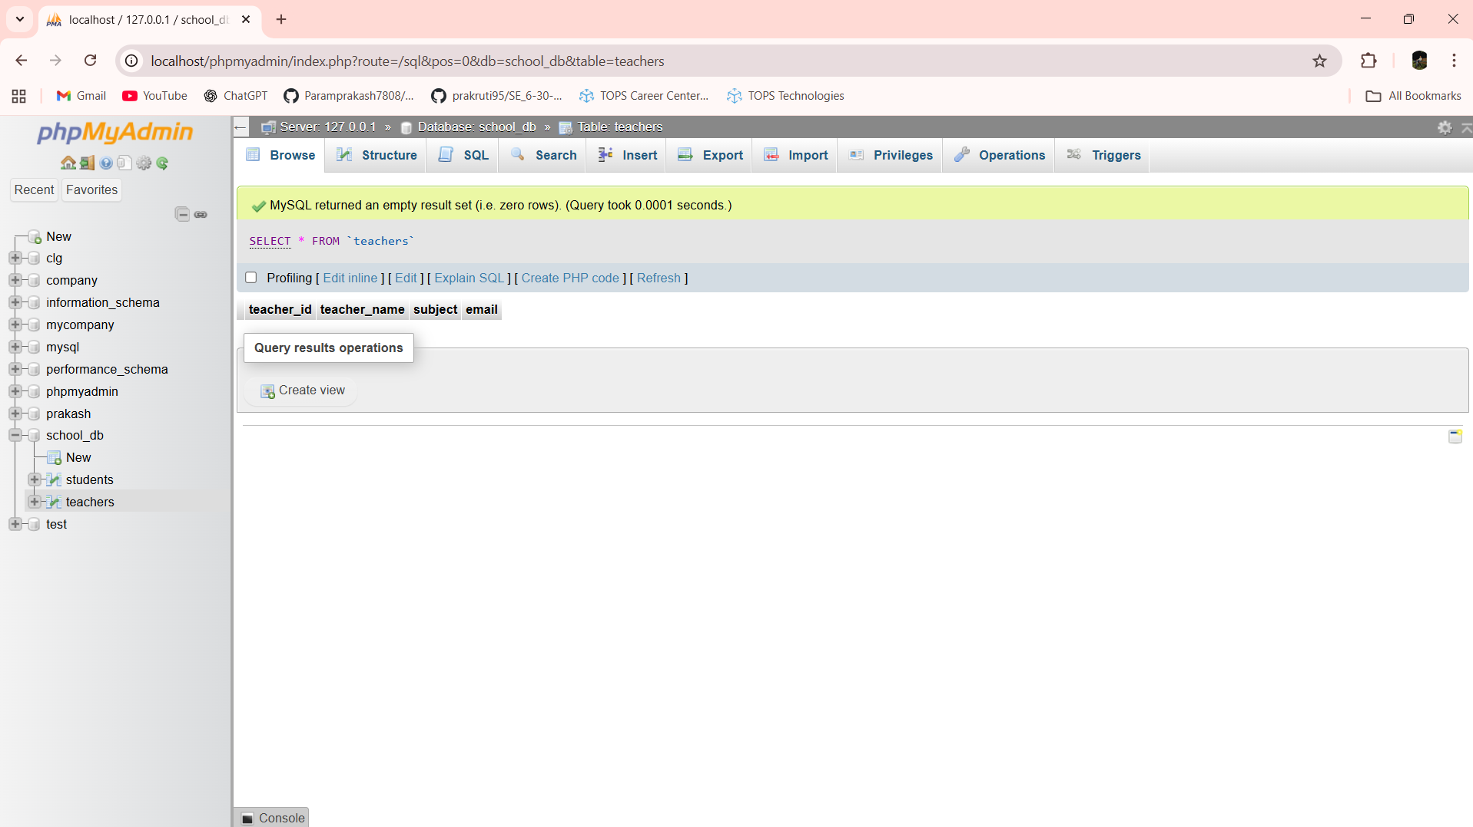

Lab 3.2: Implement a FOREIGN KEY constraint to relate the teacher_id from the teachers table with the students table.

Ans:- ALTER TABLE students ADD CONSTRAINT fk_teacher FOREIGN KEY (teacher_id) REFERENCES teachers(teacher_id)

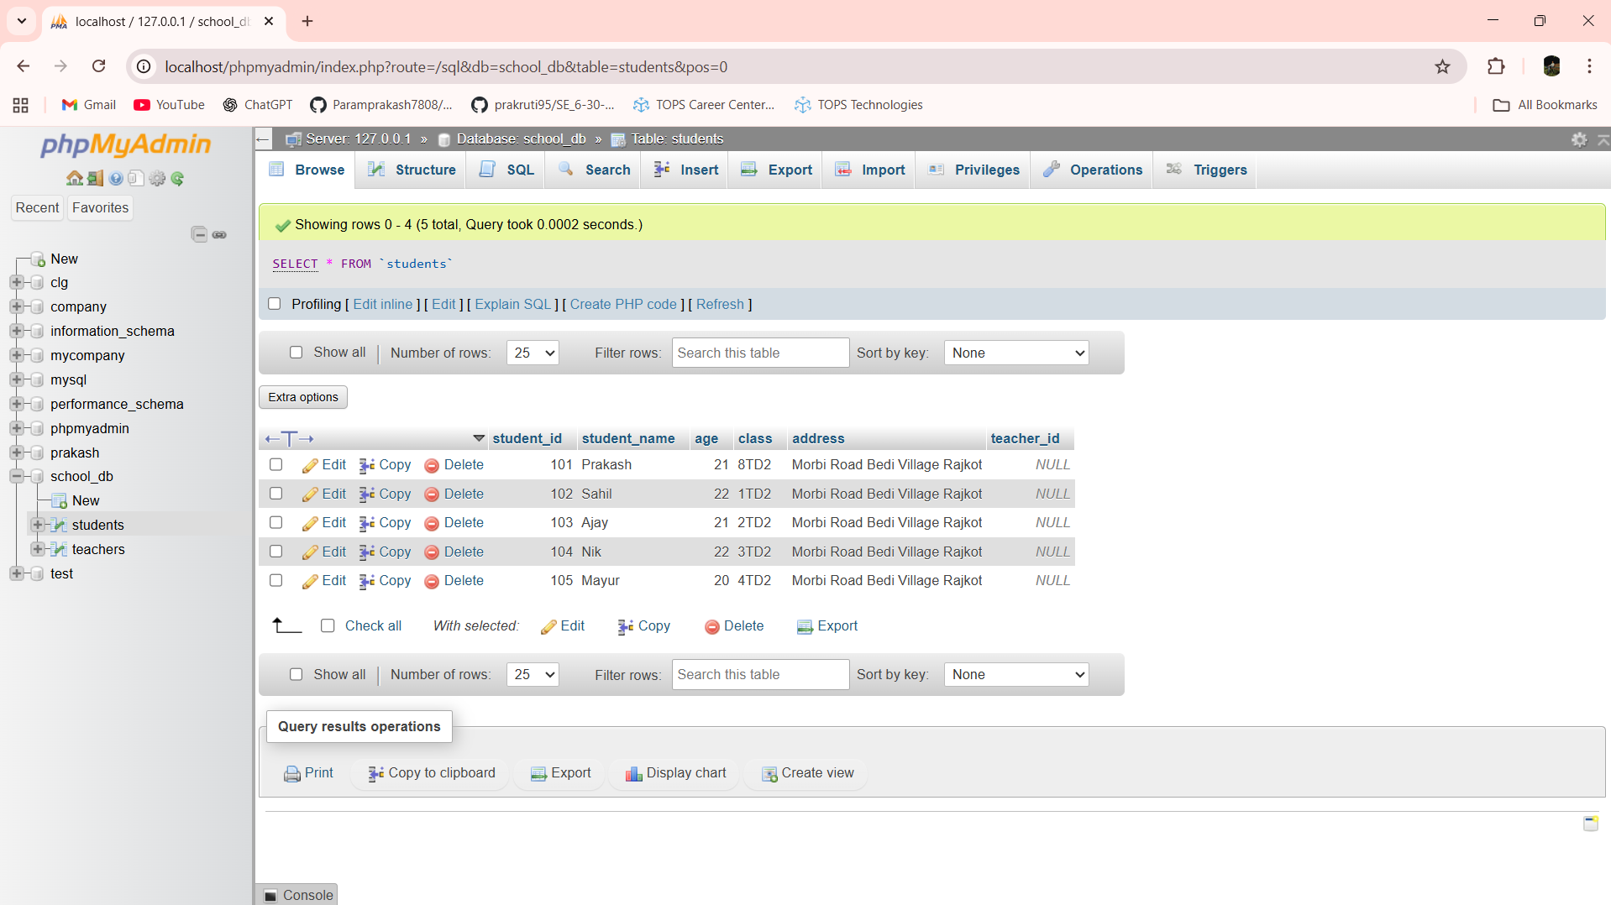

Lab 4.1: Create a table courses with columns: course_id, course_name, and course_credits. Set the course_id as the primary key.

Ans:- CREATE TABLE courses(course_id int PRIMARY KEY AUTO_INCREMENT,course_name varchar(30),course_credits int)

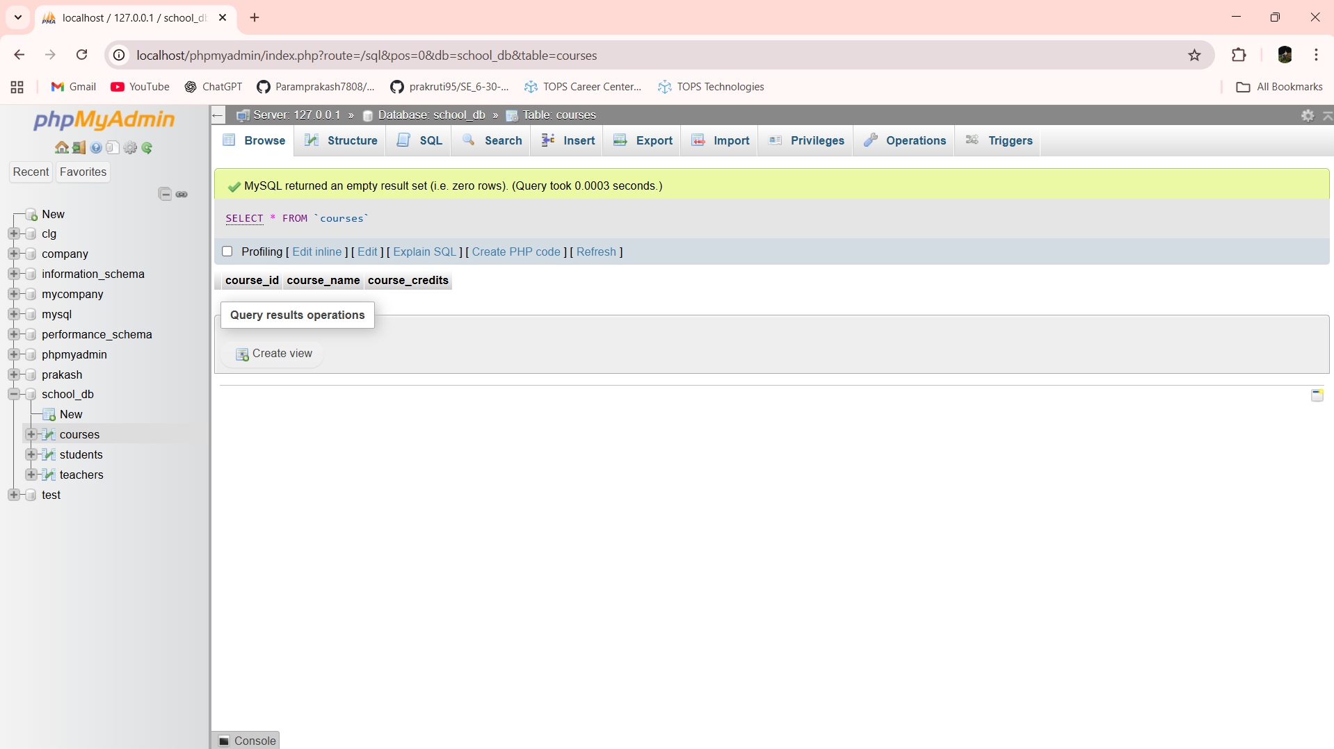

Lab 4.2: Use the CREATE command to create a database university_db.

Ans:- CREATE DATABASE university_db

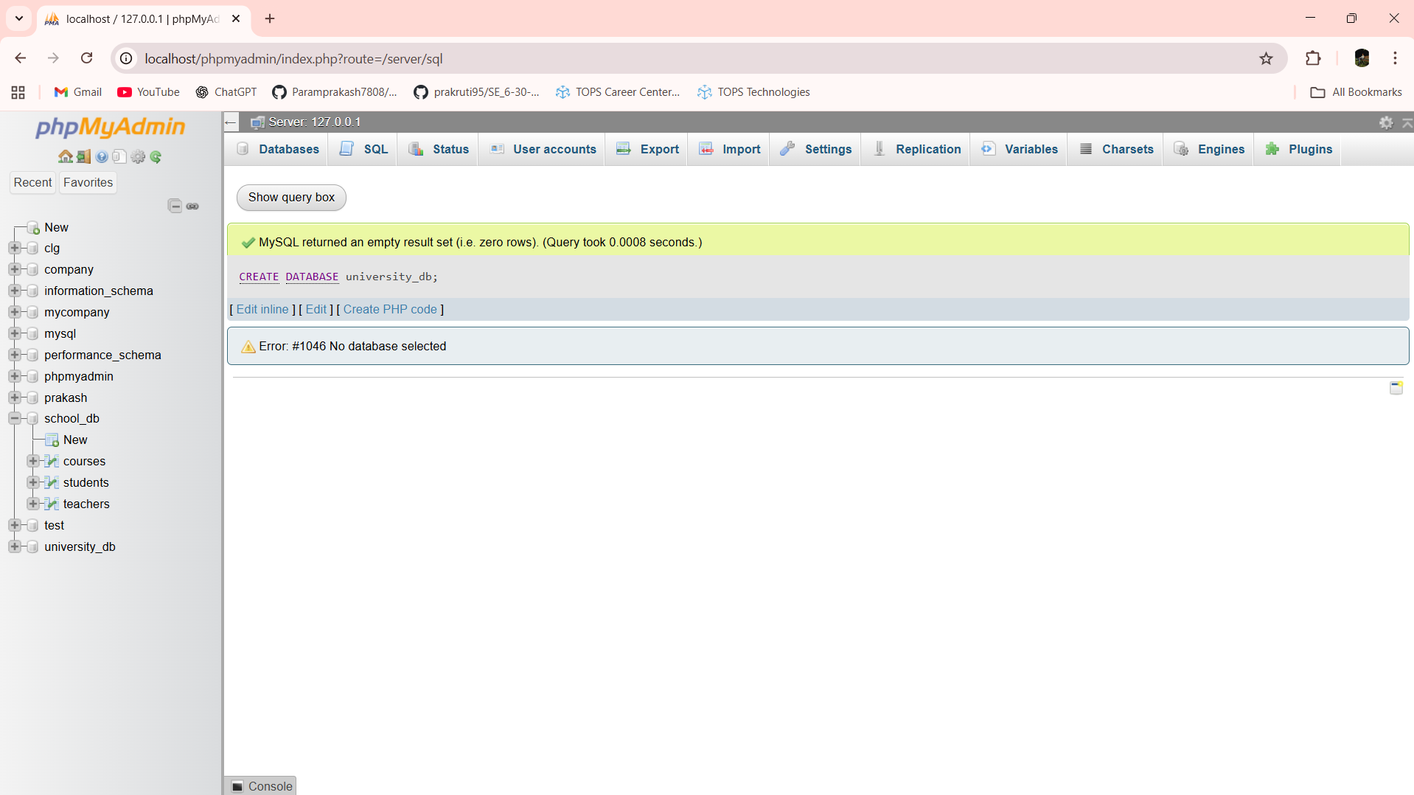

Lab 5.1: Modify the courses table by adding a column course_duration using the ALTER command.

Ans:- ALTER TABLE courses ADD course_duration varchar(30)

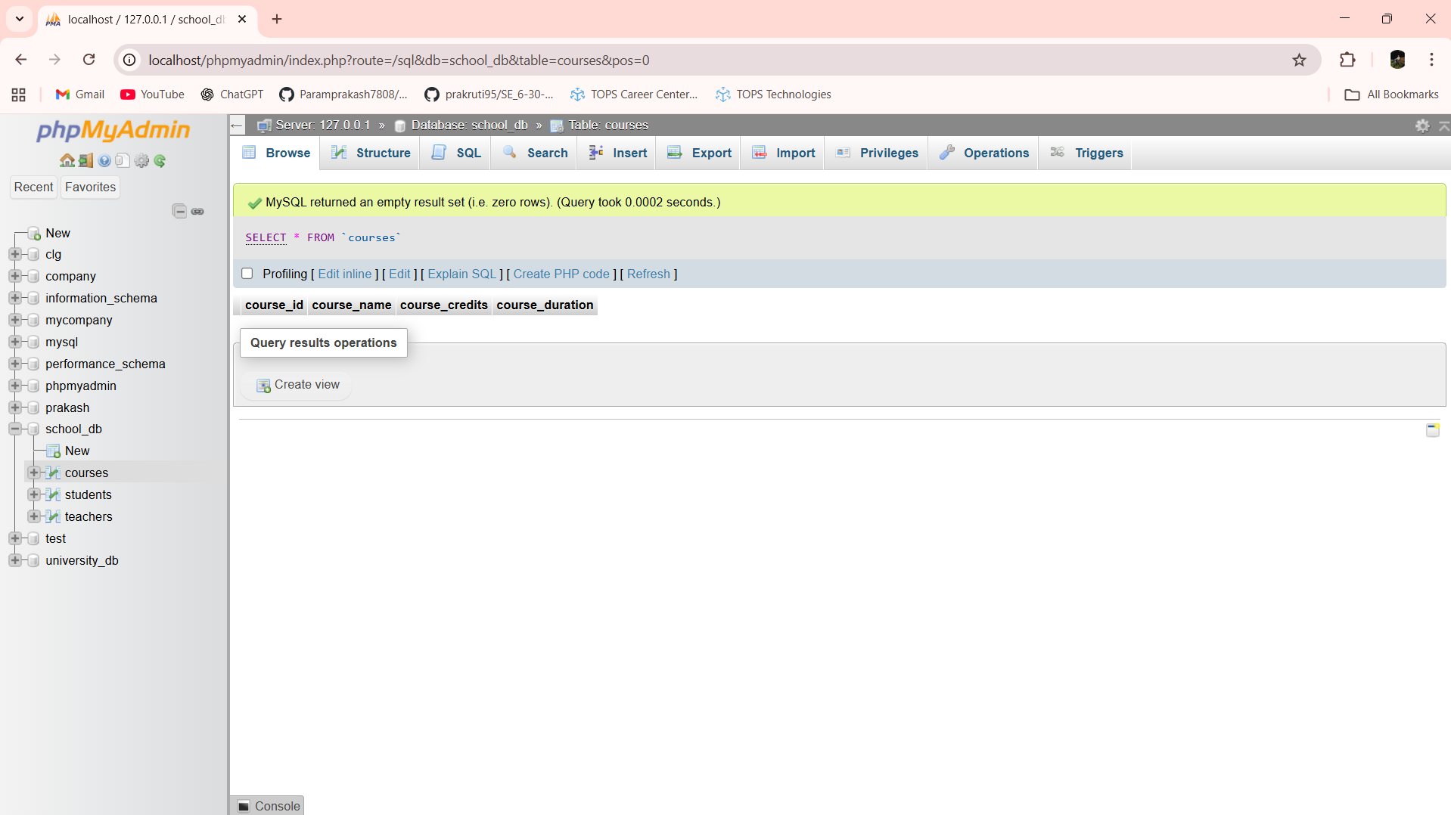

Lab 5.2: Drop the course_credits column from the courses table.

Ans:- ALTER TABLE courses DROP COLUMN course_credits

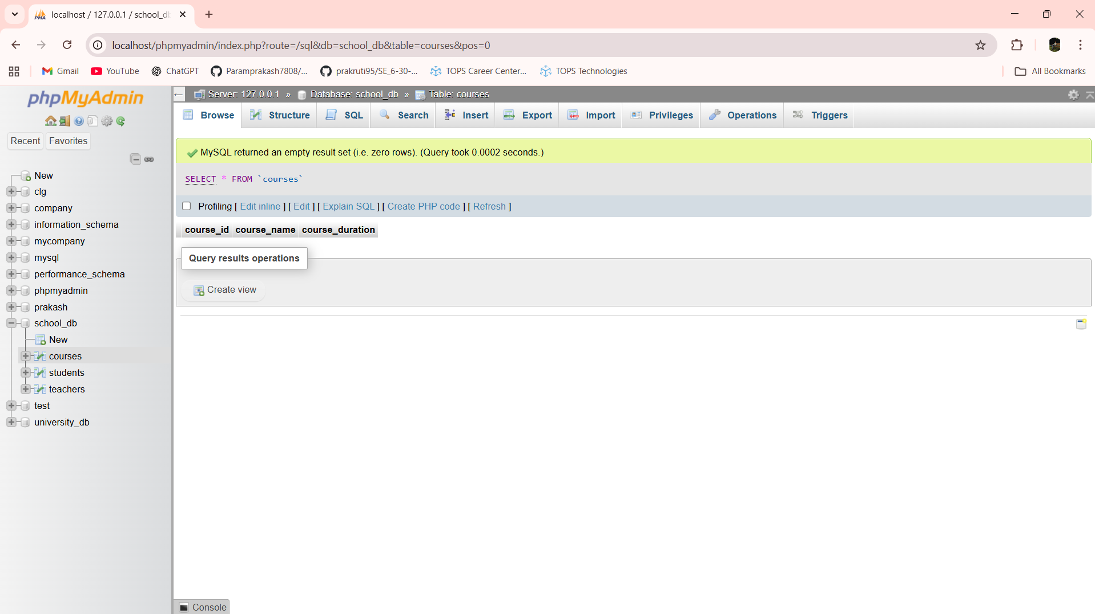

Lab 6.1: Drop the teachers table from the school_db database.

Ans:- DROP TABLE teachers

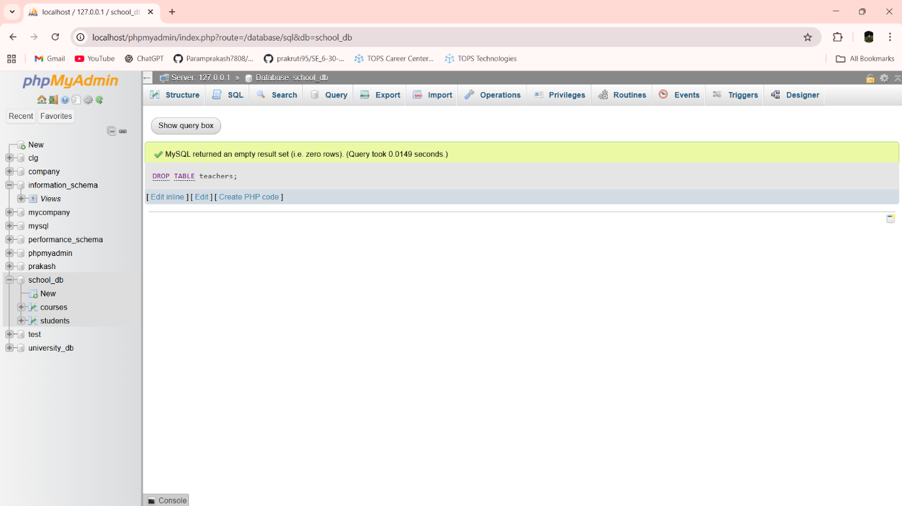

Lab 6.2: Drop the students table from the school_db database and verify that the table has been removed.

Ans:- DROP TABLE students

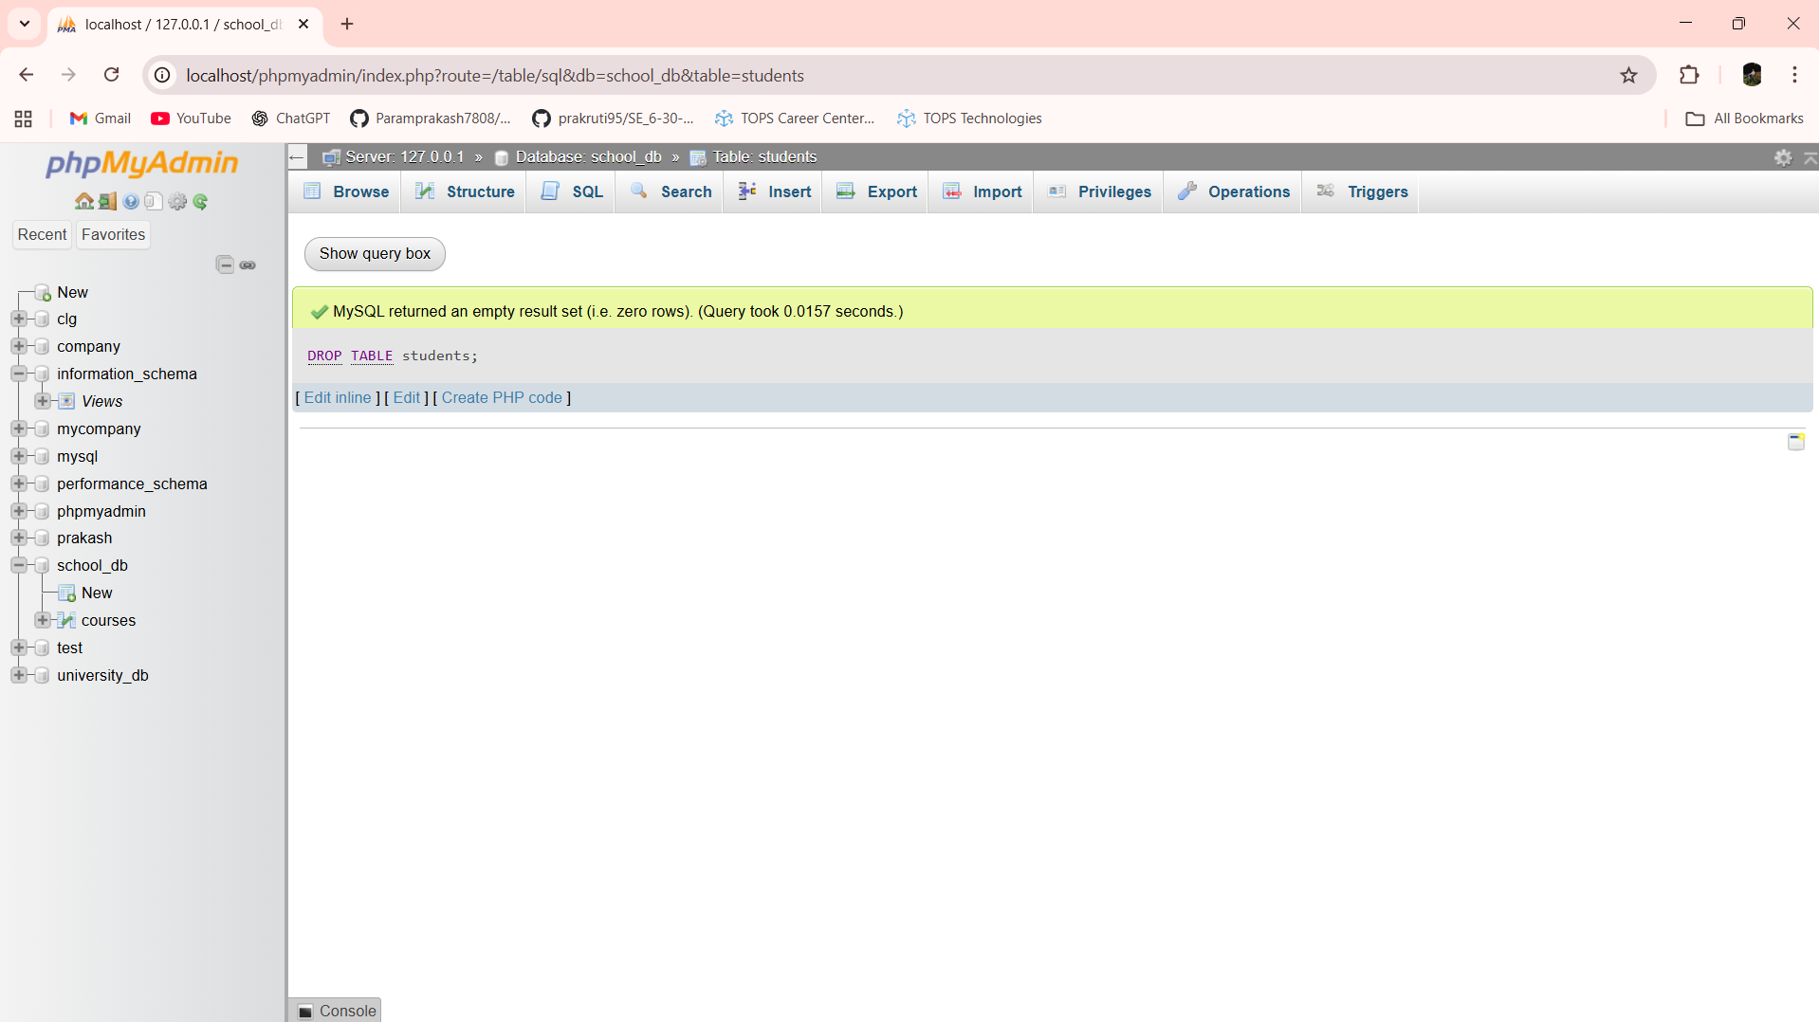

Lab 7.1: Insert three records into the courses table using the INSERT command.

Ans:- INSERT INTO courses (course_id,course_name,course_duration) VALUES (101,'Python','6 Months')

INSERT INTO courses (course_id,course_name,course_duration) VALUES (102,'Flutter','6 Months')

INSERT INTO courses (course_id,course_name,course_duration) VALUES (103,'Java','6 Months')

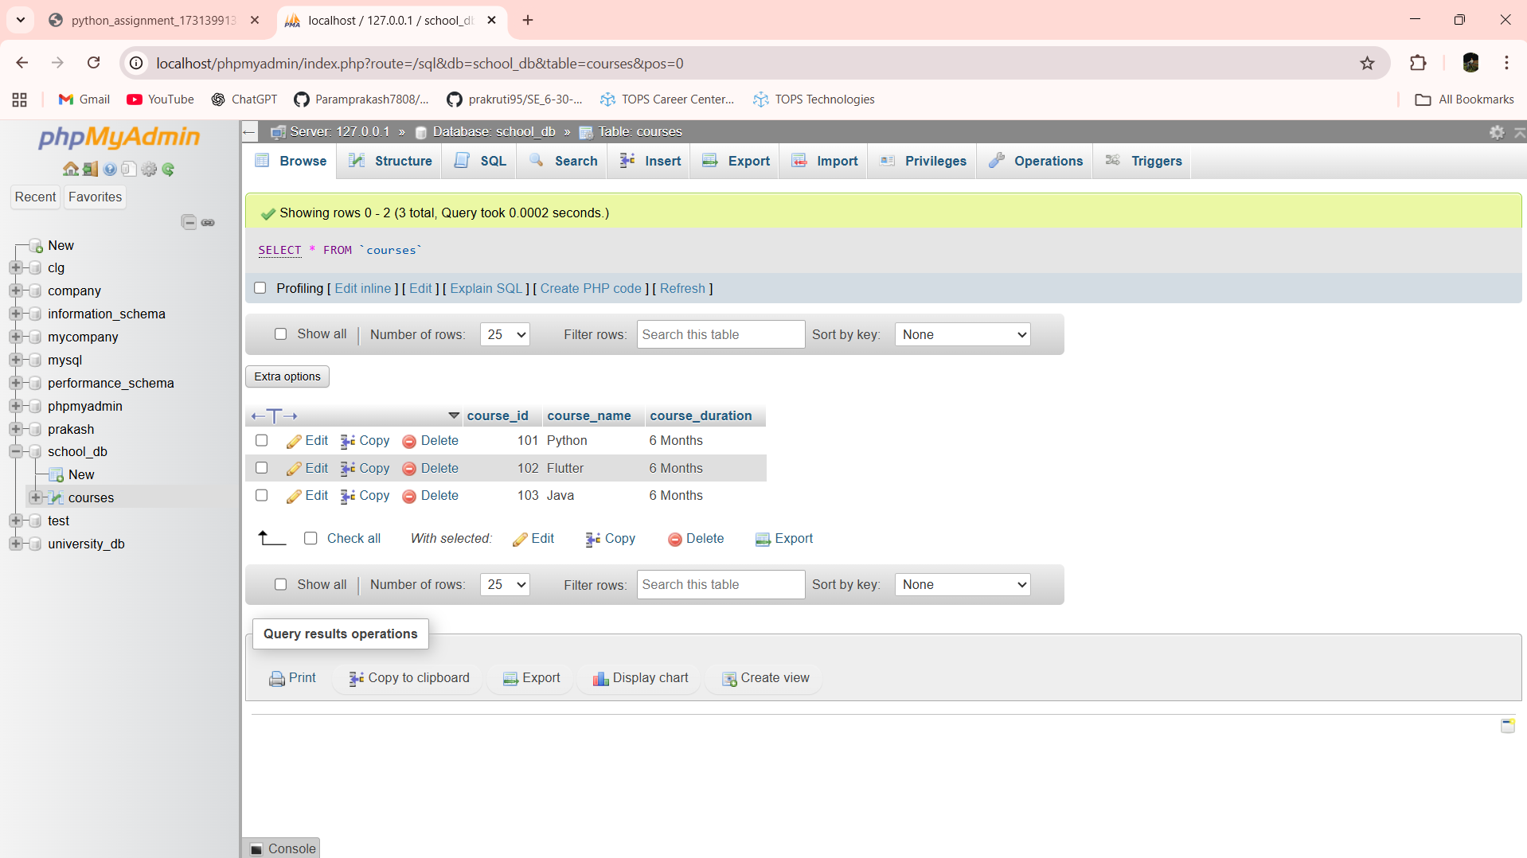

Lab 7.2: Update the course duration of a specific course using the UPDATE command.

Ans:- UPDATE courses SET course_duration = '7 Months' WHERE course_id = 103

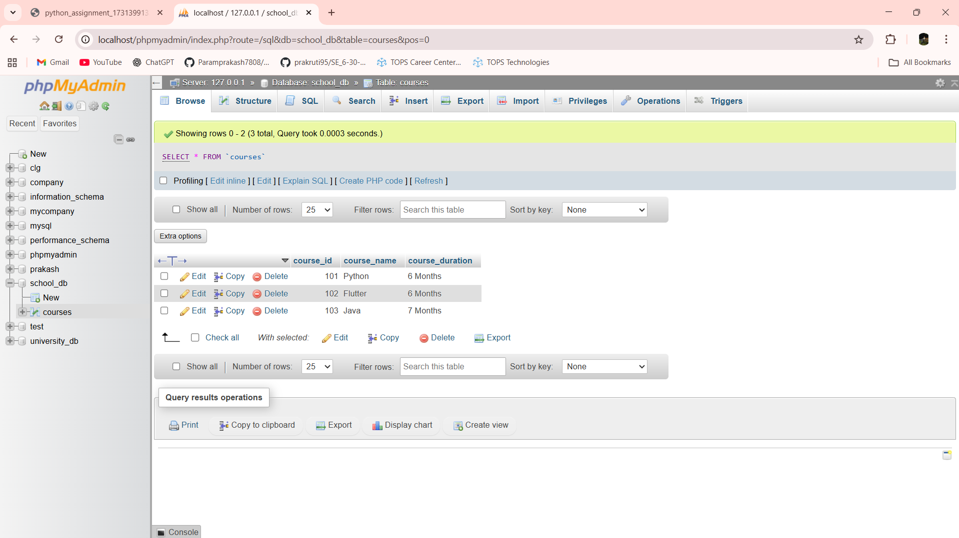

Lab 7.3: Delete a course with a specific course_id from the courses table using the DELETE command.

Ans:- DELETE FROM courses WHERE course_id = 103

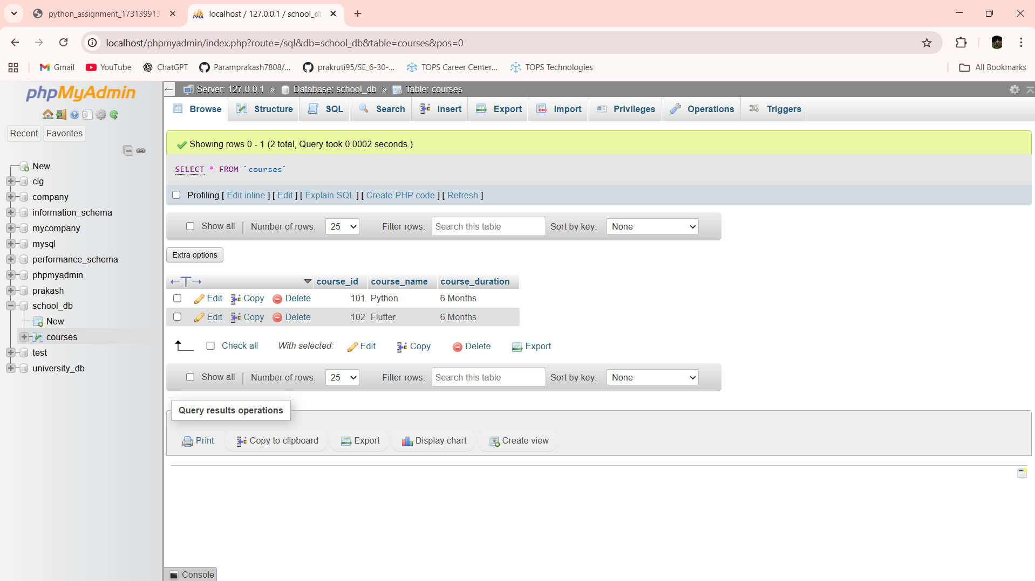

Lab 8.1: Retrieve all courses from the courses table using the SELECT statement.

Ans:- SELECT * FROM courses

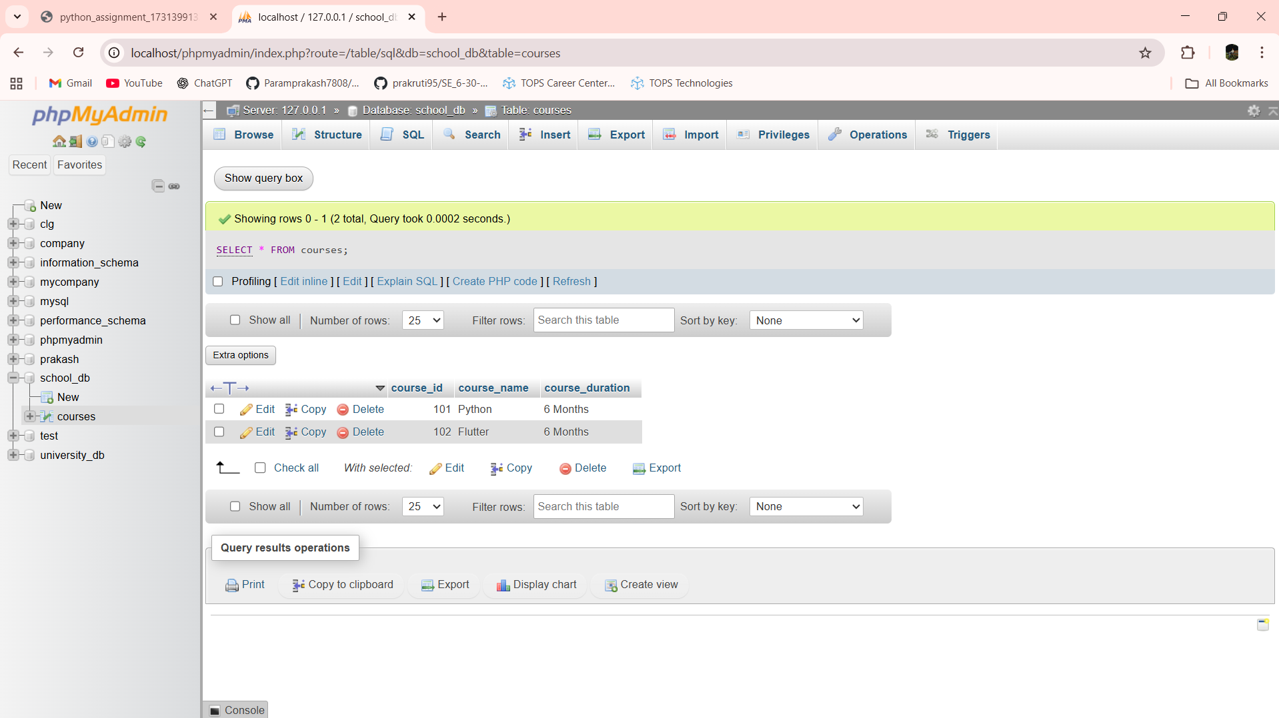

Lab 8.2: Sort the courses based on course_duration in descending order using ORDER BY.

Ans:- SELECT * FROM courses ORDER BY course_duration DESC

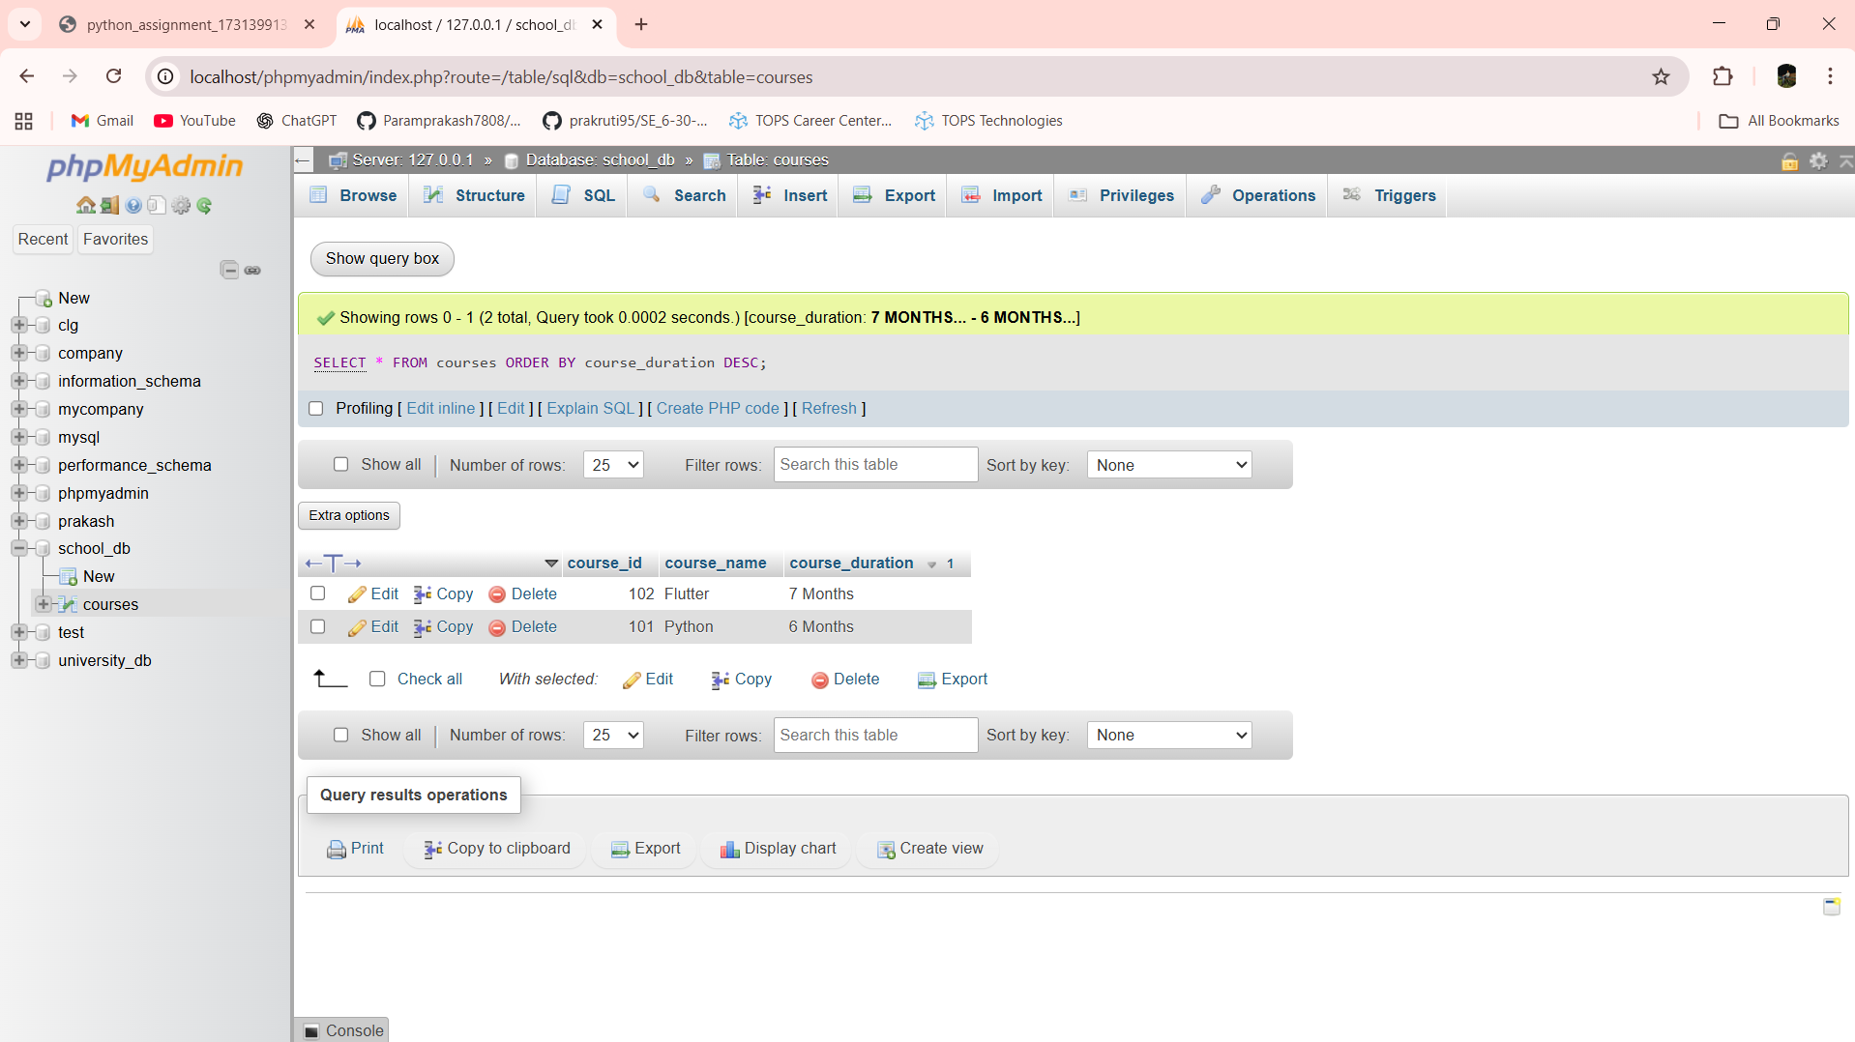

Lab 8.3: Limit the results of the SELECT query to show only the top two courses using LIMIT.

Ans:- SELECT * FROM courses LIMIT 2

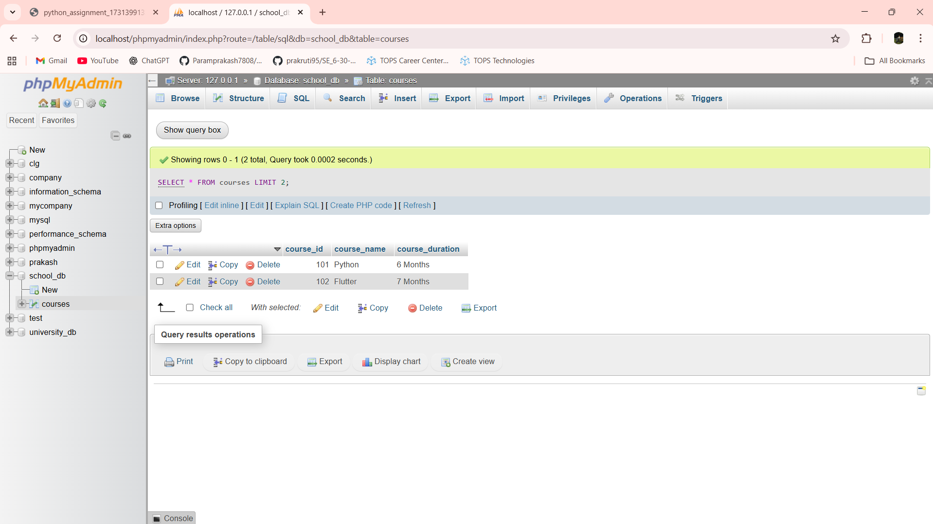

Lab 9.1: Create two new users user1 and user2 and grant user1 permission to SELECT from the courses table.

Ans:-

Lab 9.2: Revoke the INSERT permission from user1 and give it to user2.

Ans:-

Lab 10.1: Insert a few rows into the courses table and use COMMIT to save the changes.

Ans:-

Lab 10.2: Insert additional rows, then use ROLLBACK to undo the last insert operation.

Ans:-

Lab 10.3: Create a SAVEPOINT before updating the courses table, and use it to roll back specific changes.

Ans:-

Lab 11.1: Create two tables: departments and employees. Perform an INNER JOIN to display employees along with their respective departments.

Ans:- CREATE TABLE departments (dept_id INT PRIMARY KEY,dept_name VARCHAR(30))

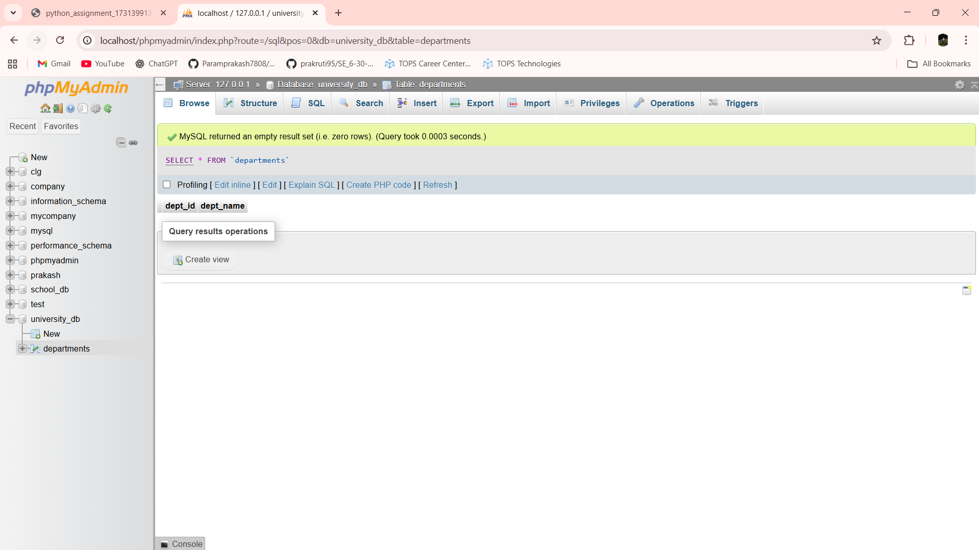

INSERT INTO departments VALUES(1, 'HR'),(2, 'IT'),(3, 'Finance')

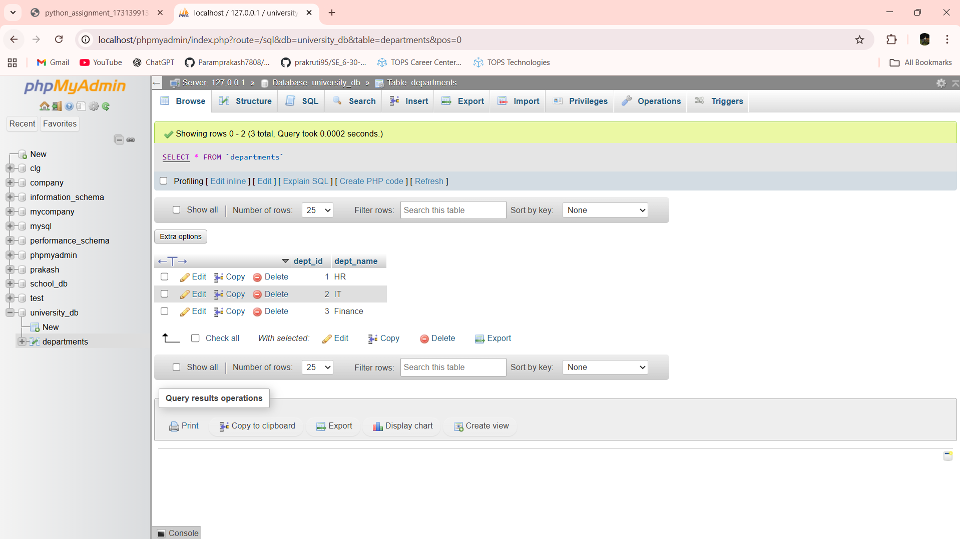

CREATE TABLE employees (emp_id INT PRIMARY KEY,emp_name VARCHAR(50),dept_id INT,FOREIGN KEY (dept_id) REFERENCES departments(dept_id))

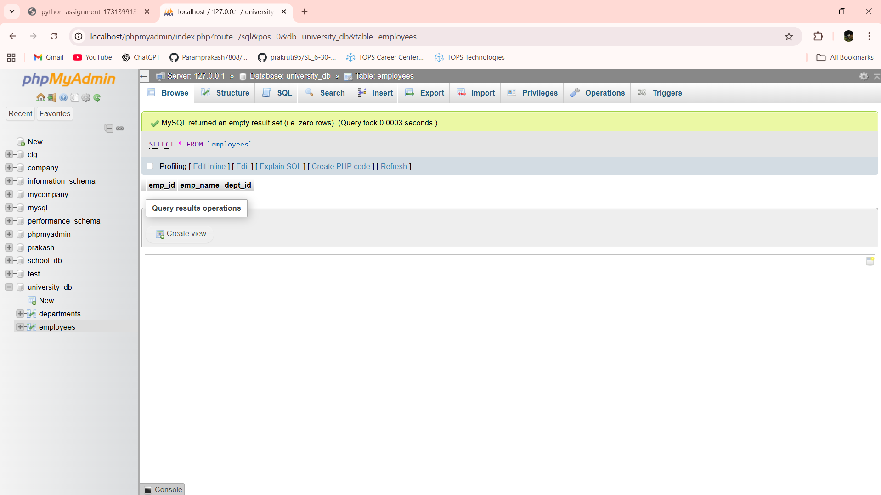

INSERT INTO employees VALUES(101, 'Sahil', 1),(102, 'Ajay', 2),(103, 'Mayur', 2)

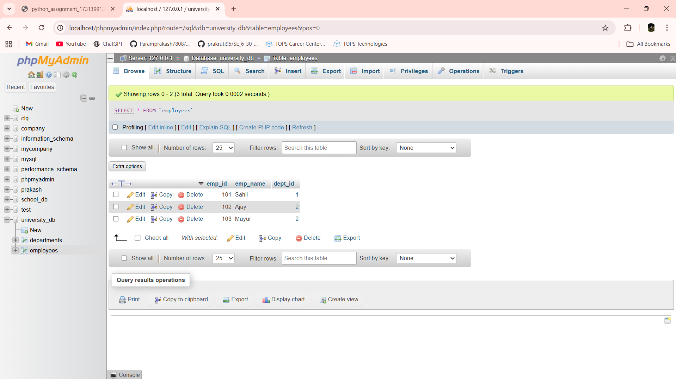

SELECT employees.emp_name, departments.dept_name FROM employees INNER JOIN departments ON employees.dept_id = departments.dept_id

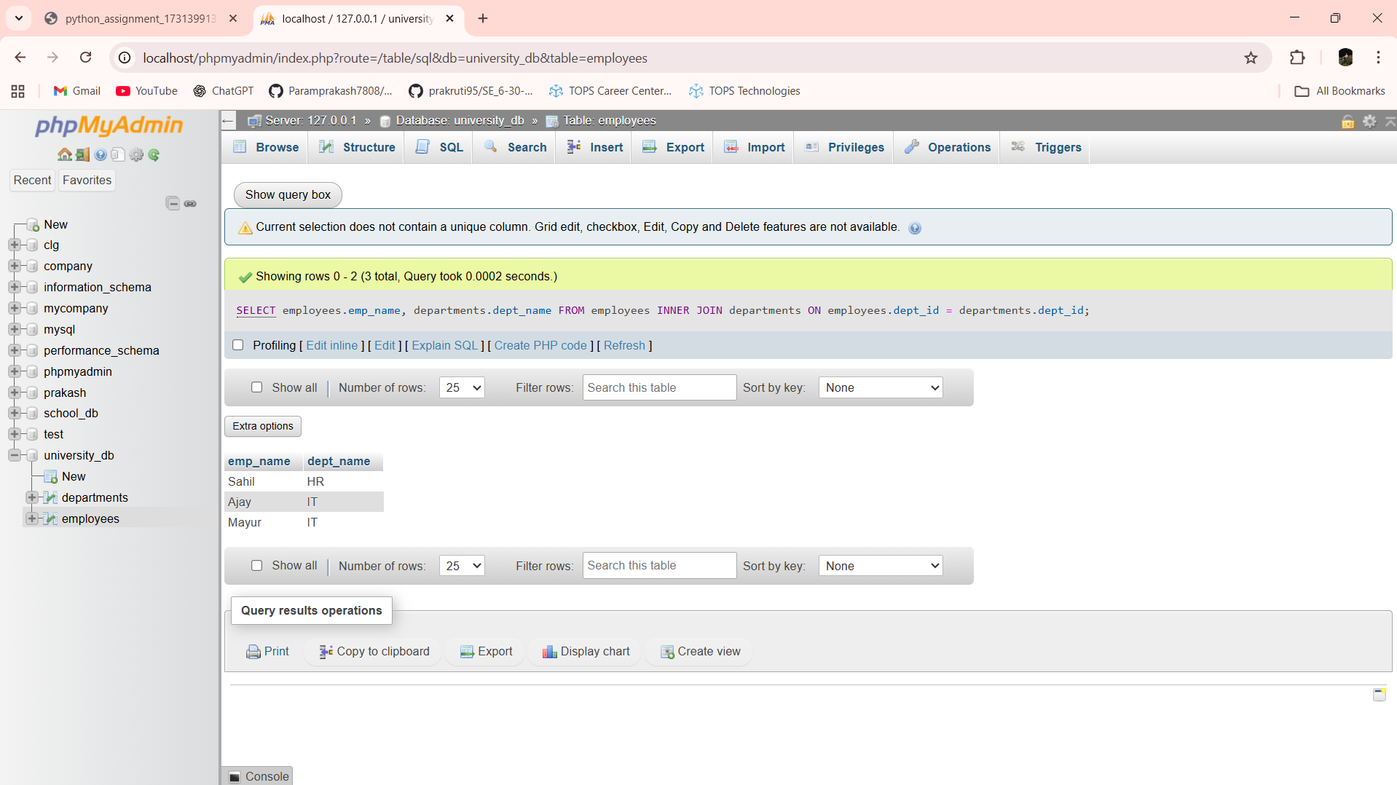

Lab 11.2: Use a LEFT JOIN to show all departments, even those without employees.

Ans:- SELECT departments.dept_name, employees.emp_name FROM departments LEFT JOIN employees ON departments.dept_id = employees.dept_id

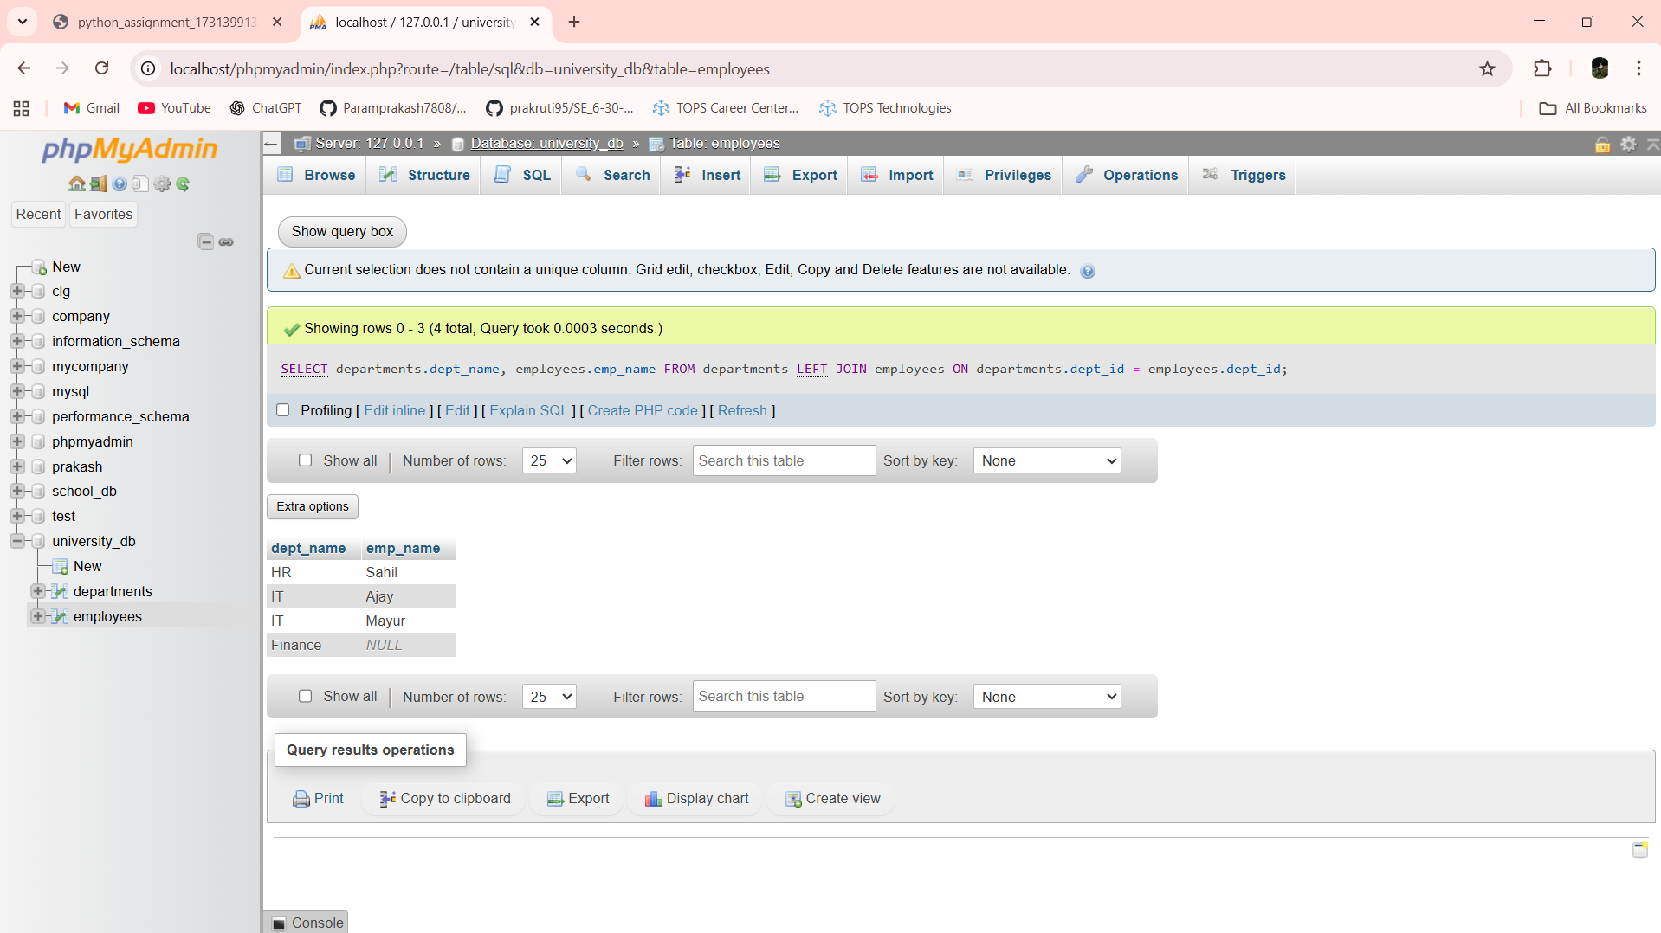

Lab 12.1: Group employees by department and count the number of employees in each department using GROUP BY.

Ans:- SELECT dept_id, COUNT(*) AS total_employees FROM employees GROUP BY dept_id

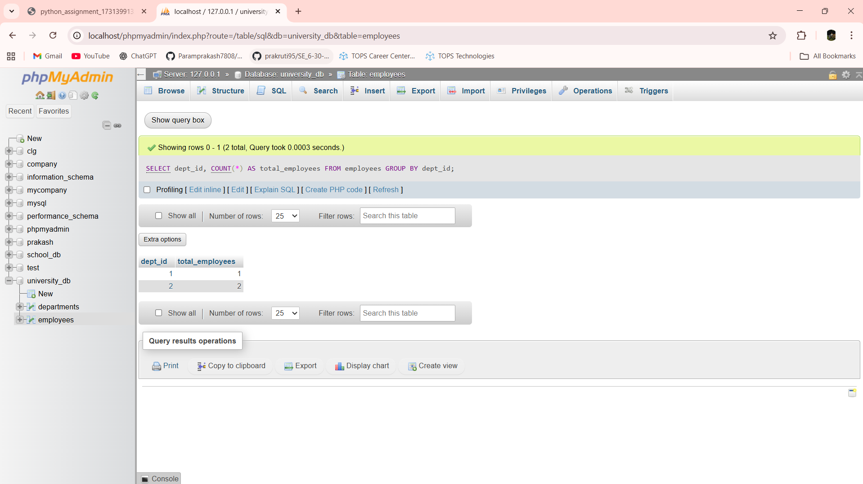

Lab 12.2: Use the AVG aggregate function to find the average salary of employees in each department.

Ans:- SELECT dept_id, AVG(salary) AS average_salary FROM employees GROUP BY dept_id

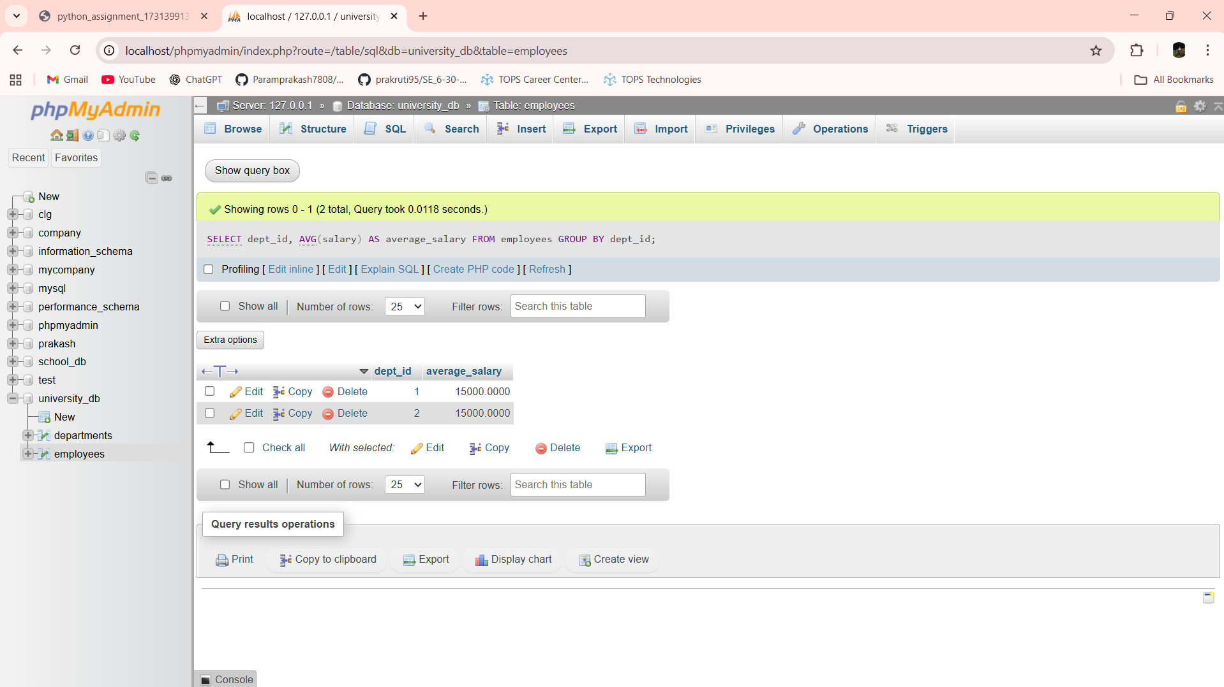

Lab 13.1: Write a stored procedure to retrieve all employees from the employees table based on department.

Ans:- DELIMITER $$

CREATE PROCEDURE getEmployeesByDept(IN p_dept_id INT)

BEGIN

SELECT * FROM employees WHERE dept_id = p_dept_id;

END $$

DELIMITER ;

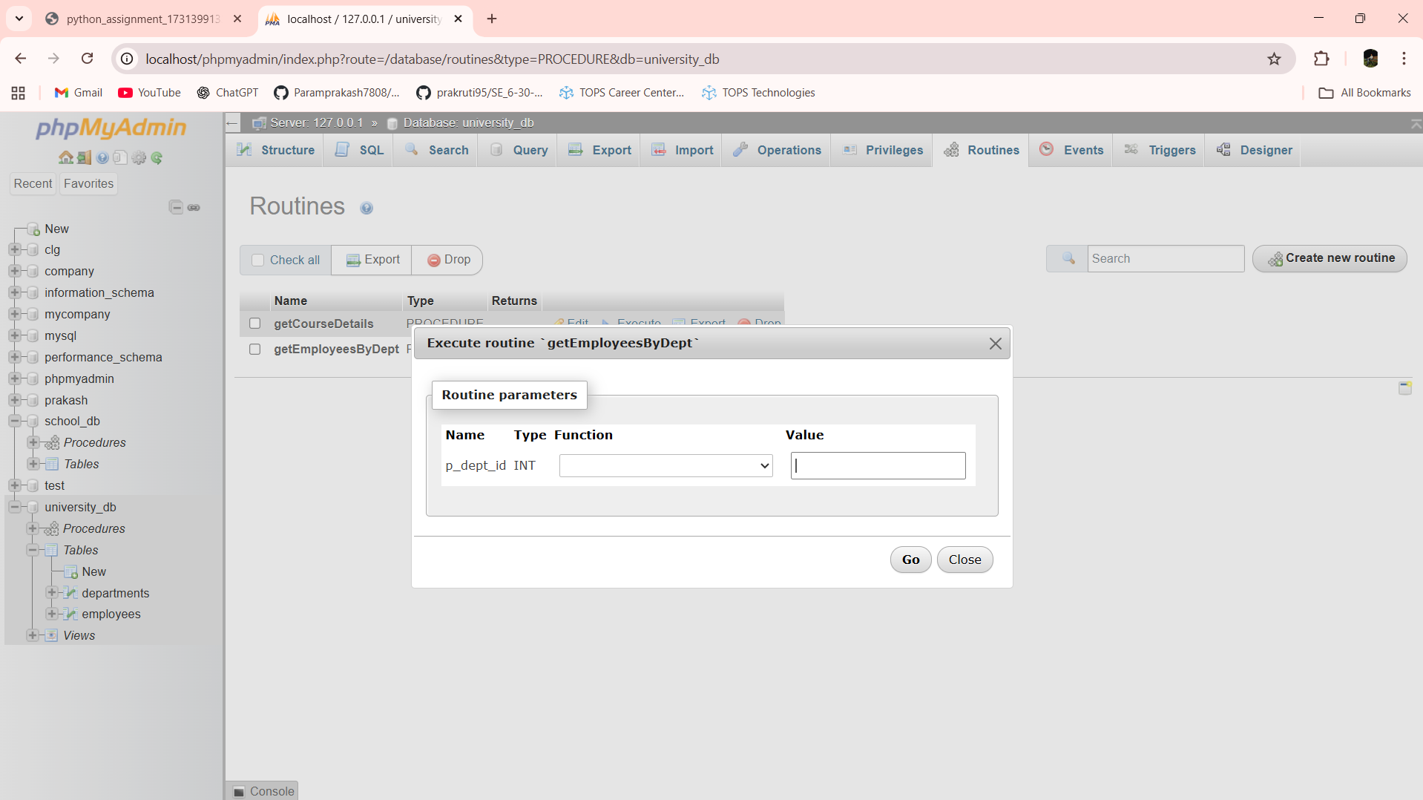

CALL getEmployeesByDept(2);

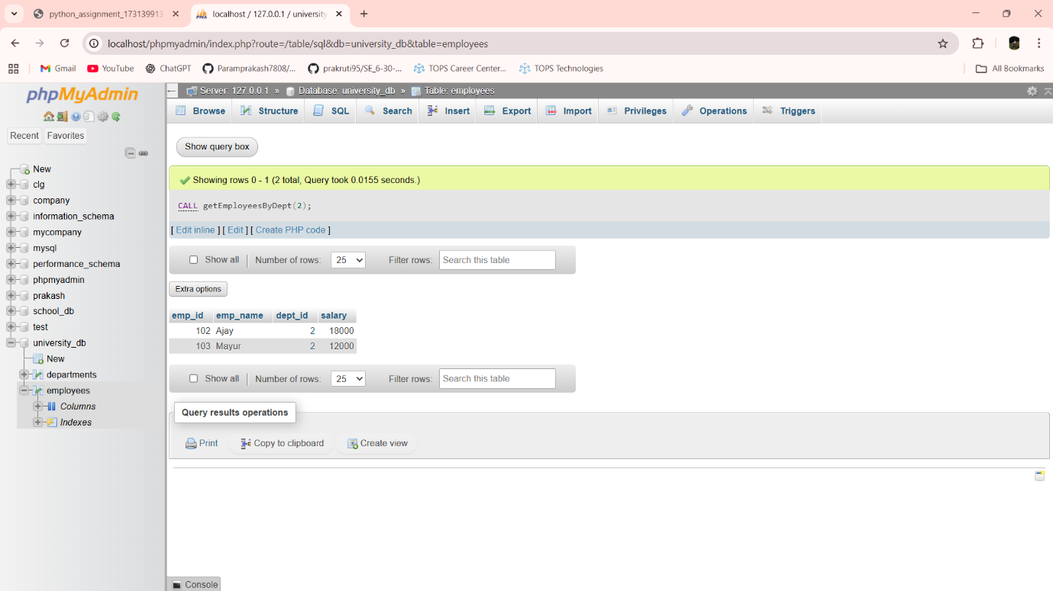

Lab 13.2: Write a stored procedure that accepts course_id as input and returns the course details.

Ans:- DELIMITER $$

CREATE PROCEDURE getCourseDetails(IN p_course_id INT)

BEGIN

SELECT *

FROM courses

WHERE course_id = p_course_id;

END $$

DELIMITER ;

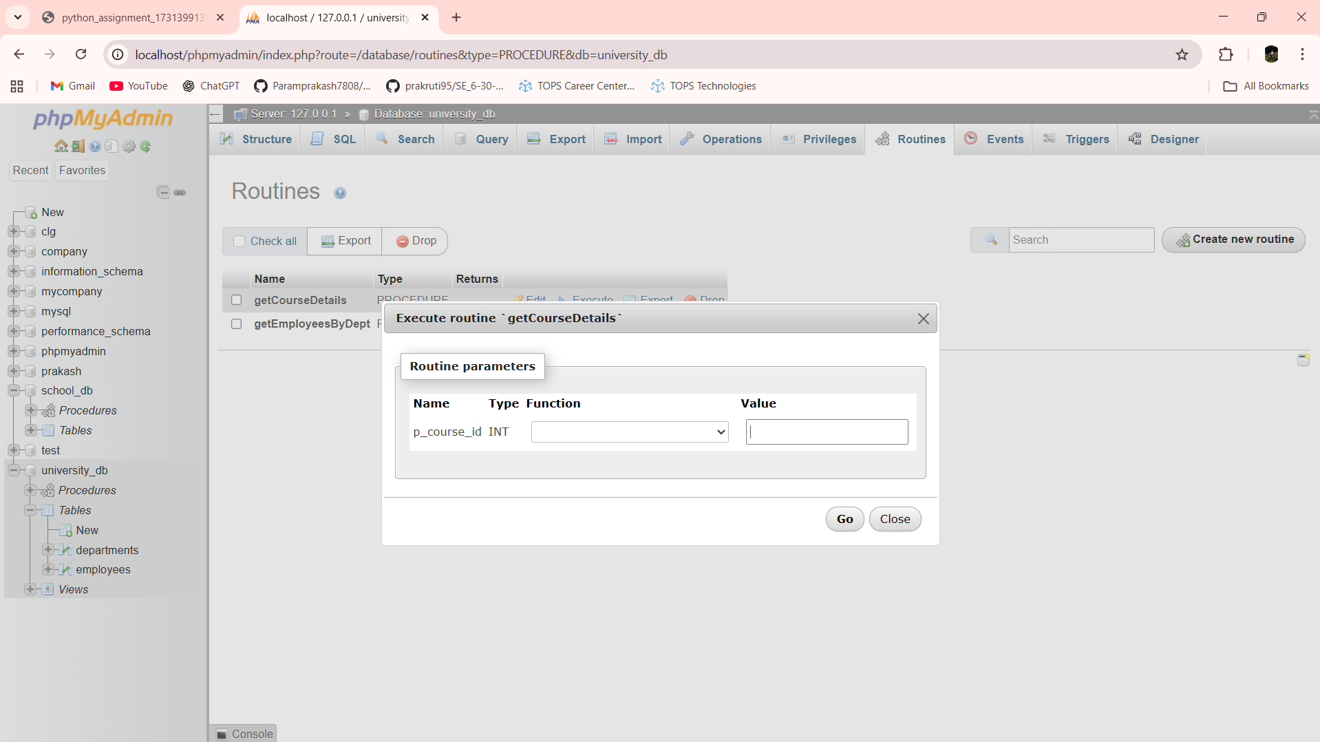

CALL getCourseDetails(101)

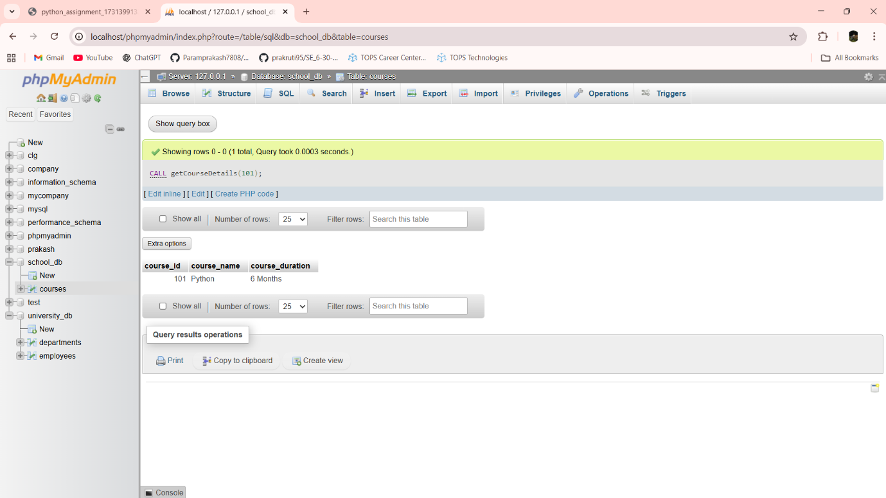

Lab 14.1: Create a view to show all employees along with their department names.

Ans:- CREATE VIEW emp_dept_view AS

SELECT

e.emp_id,

e.emp_name,

d.dept_name,

e.salary

FROM employees e

INNER JOIN departments d

ON e.dept_id = d.dept_id;

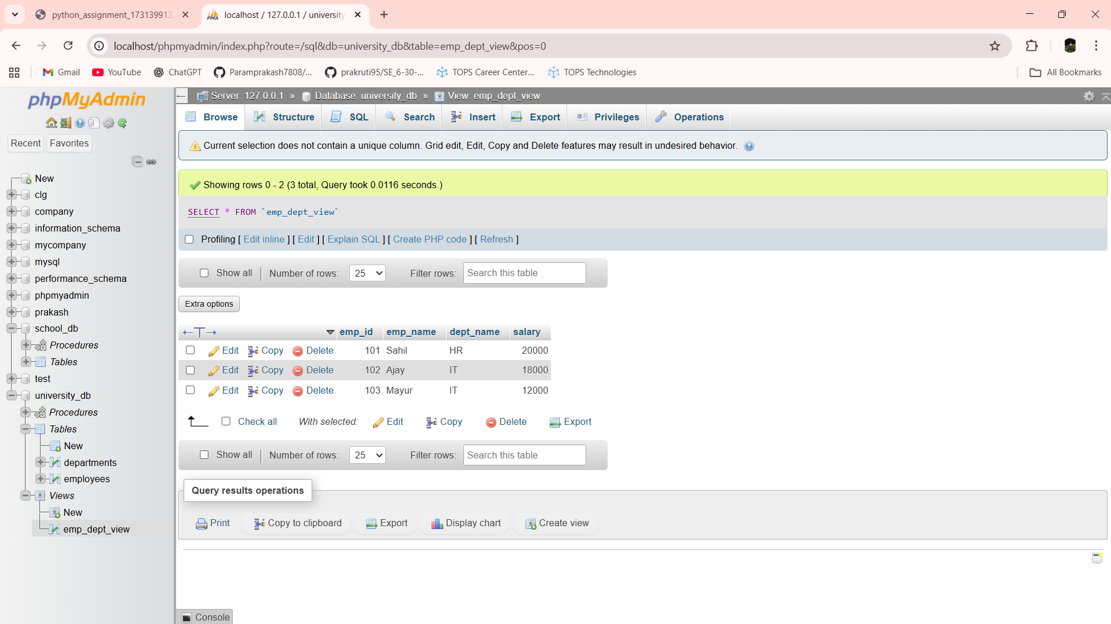

Lab 14.2: Modify the view to exclude employees whose salaries are below $50,000.

Ans:- CREATE OR REPLACE VIEW emp_dept_view AS

SELECT

e.emp_id,

e.emp_name,

d.dept_name,

e.salary

FROM employees e

INNER JOIN departments d

ON e.dept_id = d.dept_id

WHERE e.salary >= 50000;

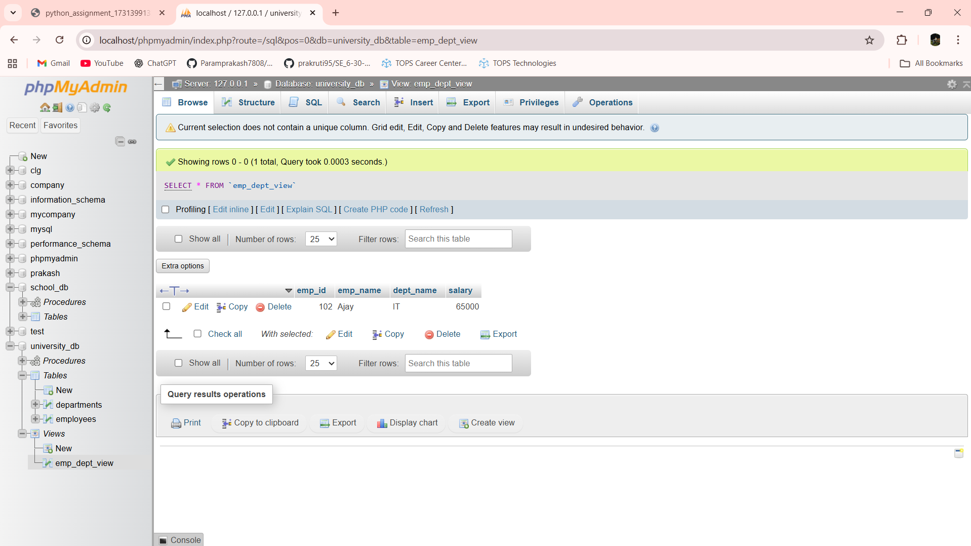

Lab 15.1: Create a trigger to automatically log changes to the employees table when a new employee is added.

Ans:- CREATE TABLE employee_log (

log_id INT AUTO_INCREMENT PRIMARY KEY,

emp_id INT,

action VARCHAR(50),

log_time TIMESTAMP DEFAULT CURRENT_TIMESTAMP

);

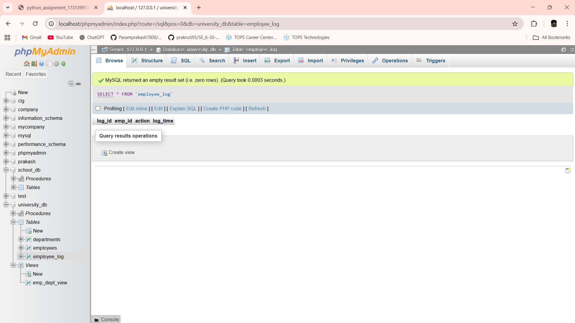

DELIMITER $$

CREATE TRIGGER after_employee_insert

AFTER INSERT ON employees

FOR EACH ROW

BEGIN

INSERT INTO employee_log (emp_id, action)

VALUES (NEW.emp_id, 'INSERT');

END $$

DELIMITER ;

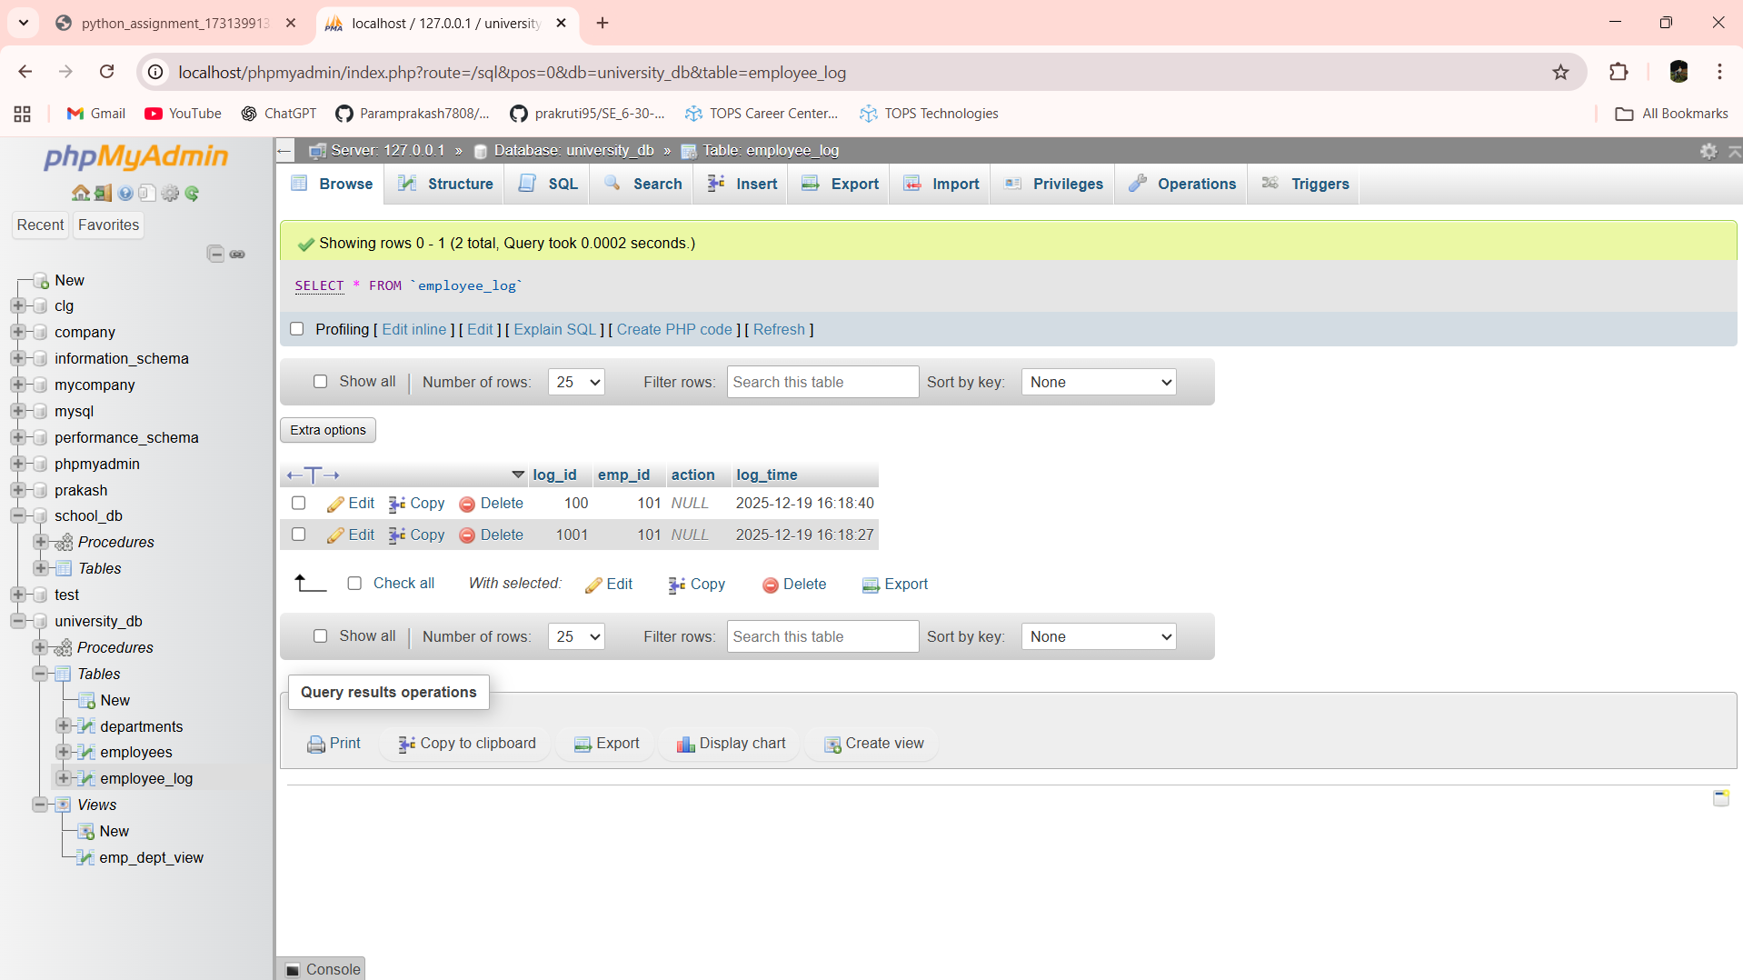

Lab 15.2: Create a trigger to update the last_modified timestamp whenever an employee record is updated.

Ans:- DELIMITER $$

CREATE TRIGGER before_employee_update

BEFORE UPDATE ON employees

FOR EACH ROW

BEGIN

SET NEW.last_modified = CURRENT_TIMESTAMP;

END $$

DELIMITER ;

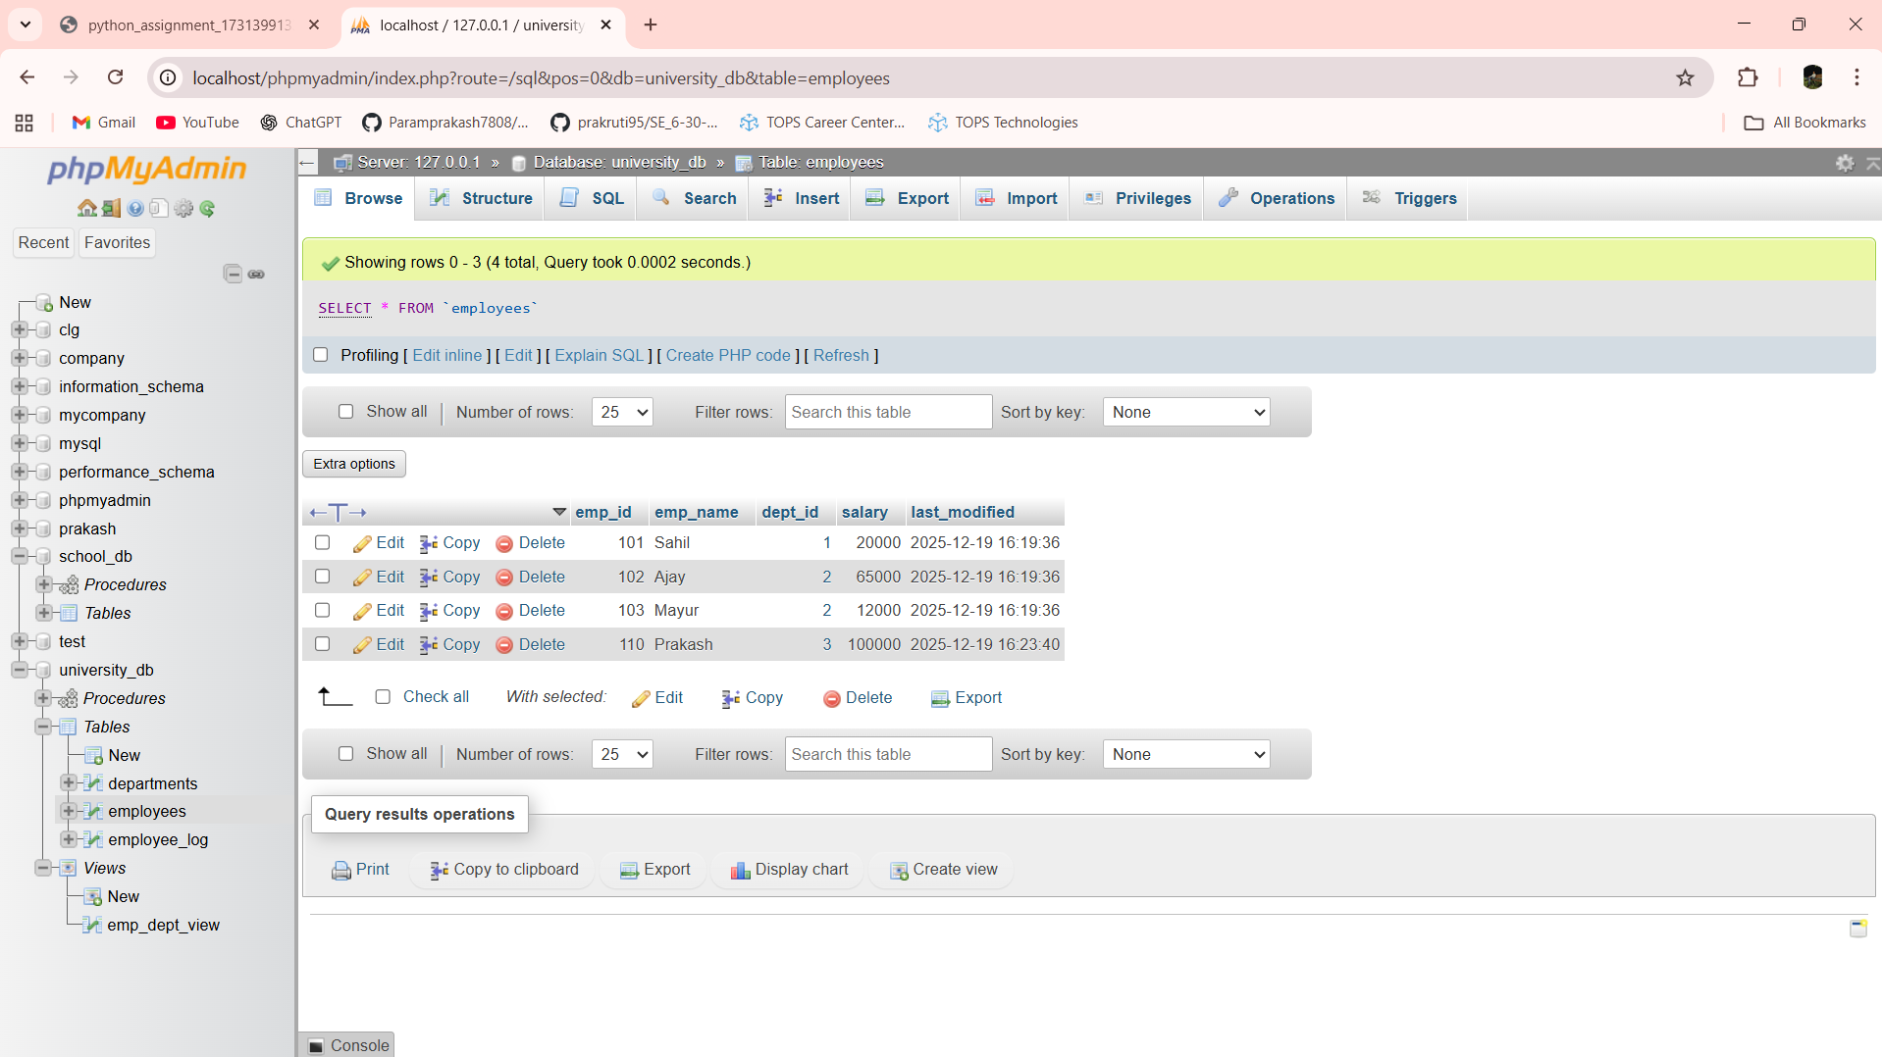

Lab 16.1: Write a PL/SQL block to print the total number of employees from the employees table.

Ans:-

Lab 16.2: Create a PL/SQL block that calculates the total sales from an orders table.

Ans:-